# **Chapter 1 – Introduction**

## **Introduction to projects**

Life/Business is getting more advance by the next day, every small business is getting into web business. If you used to do business in your local town then now with the help of websites you can do business in whole country or even in other countries.

Like this Dance Studio is a small dance learning and event organizing organization which is giving dance lesson to students from their local area and also organizing some small events in their studio. Dance studio has many achievements in dancing platform but not many people know about its name. That’s why Dance Studio wants to make its own websites so it can attract more students/customers.

Dance Studio is an online website for dance studio where students or everyone can find out information about dance studio. Information like faculty, facilities, coaches, records, achievement of club, events, etc. Guardian can surf the website for events that club is going to take part in from anywhere and decide if their children can take part in it. New members can first research about studio in website and book desirable class from home.

## **Background and problem statement**

Nowadays there are many dance studios available within small area and we don’t know if they are any good than any other dance studios. Students joins studios not because they know what that dance studio is capable of but they join them with information like their friends are attending that studios or they heard that the studios are great. Now in a developing country like our not many dance studios have their own websites to share the information about their facilities, achievement, marketing etc. In this busy schedule guardians need to visit every dance studio to provide their children good dance lesson.

No matter what dance studio has achieved till now they can’t show everything to students and guardians every time they visit. People join because of achievement of studio and professor but showing them everything on one visit is impossible. With the help of this project dance studio can show off their achievement, facilities, faculty etc. through website.

People are getting busy day by day they don’t have time for directly visiting dance studios for research and admitting their children there. With less time and information, they may choose bad studio. To get to know what happening in dance studio they need to visit studio every time or contact them. This project makes easy access to information of studio, events, tickets etc.

## **Overview of the project**

Some features that are available in the system are given below:

* Easy registration and login system.
* Students can search class they want with keyword
* Students can book any class they want to attend
* Customer can book tickets for events they want to events
* All members can contact us through email.

## **Aims**

Project has its own scope. Scope of this project are:

* To make it easy enrollment in dance studio.
* To reduce unnecessary waste of time.
* To provide customer satisfaction.

## **1.5 Objective**

This project will focus its attention on its main objectives in its operations. Some Objectives are:

* Easy sign up and login system for users.
* To perform design and create system user friendly.
* To Simplify the task and reduce the paper work.
* Designing properly to meet the requirement.
* Deployment of the project
* They should be error free, easy to use.

# Chapter 2 – Analysis

## 2.1 Introduction to analysis

Analysis is the 2nd phase of the SDLC (Software Development Life Cycle). The main objective of analysis phase is requirements determination. This is the most important phase in software development as it works to understand the requirement of the system and helps to develop a system meeting those requirements. This is done by working through the information like who will use the product, how the user will use the product, specific information included with any special users’ requirement and studying and analyzing each requirement of the current system and defining and prioritizing users’ requirements. Analysis is the least technical phase of the SDLC and needs effective social, communication and managerial skills to be successful.

## 2.2 Methodology

A methodology is the steps that are followed when working on a project and in what order those steps should be taken. There are different types of analysis methodology like Hard System methodology, Soft System Methodology, combined soft/hard methodology, organization-oriented methodology etc. from those methodology I have chosen **Hard System methodology** for this project. Within Hard System methodology there are different methods among them I picked **Structured System Analysis and Design Methodology (SSADM).**

SSADM divides an application development project into stages, steps, modules, tasks, and provides a framework for describing projects in a way suited to managing the project.

Following are the stages of SSADM:

1. **Feasibility Study:** Feasible study of a project is to determine if the project is technically feasible, if it is feasible within the estimated cost or not, and will be profitable or not.
2. **Analysis and Requirement Specification:** All aspect of the system like hardware and software are analyzed and also investigate the current environment and then requirement specification is generated.
3. **Design:** Database design and set of program specifications are created using the logical system specification and technical system specification.
4. **Implementation:** The system is introduced to the company either directly in a phase transformation, or running in parallel with the existing system until the new system is working successfully.
5. **Testing:** This stage is done after the development of the system. In this stage all aspect of the new system is tested in order to find errors in the system and fix them to ensure robustness and reliability of the system.
6. **Maintenance:** To ensure there are no big problems in system regular maintenance is necessary. It also ensures robustness and reliability of the system.

A **data-flow diagram (DFD)** is a way of graphically representing a flow of a data of a process or an information system. And a good data-flow diagram makes it easy to understand the flow of data through the system.

Data Flow diagram of admin is given below:

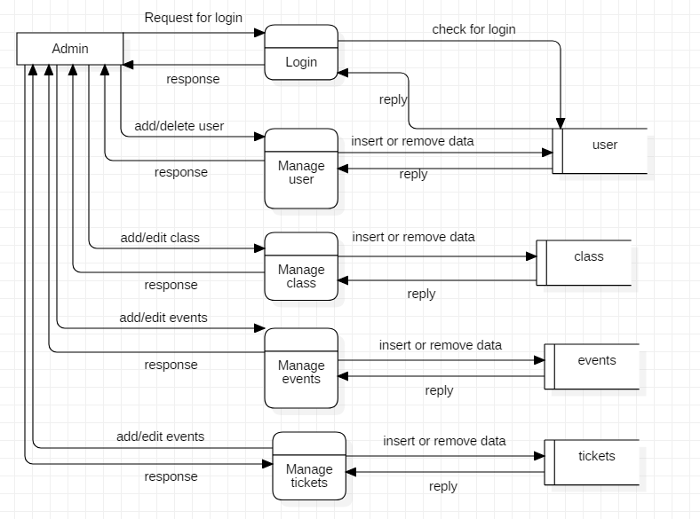

Figure 1: Data Flow Diagram of Admin

Data Flow diagram of user is given below:

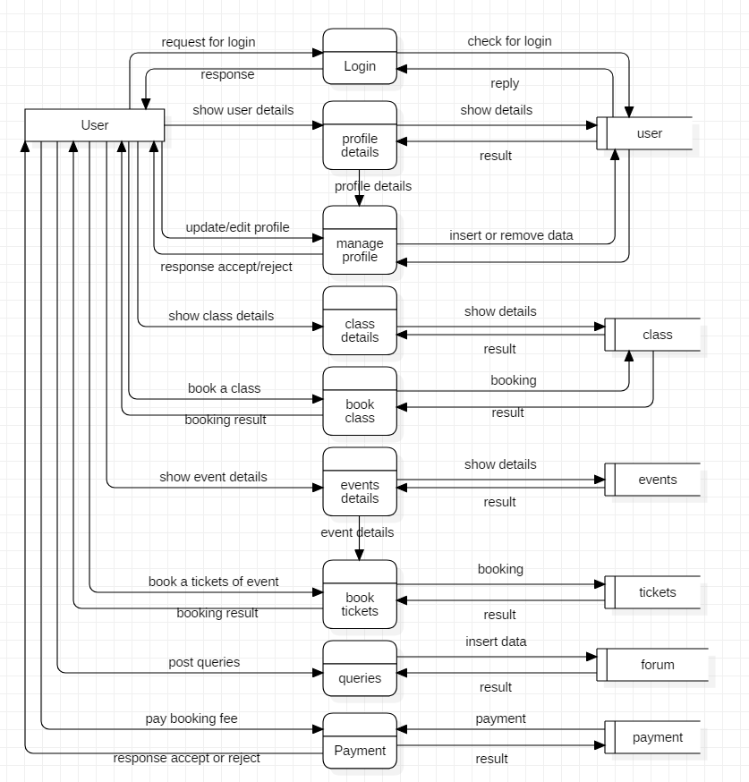

Figure 2: Data Flow Diagram user

## 2.3 Feasibility Study

A feasibility study is an analysis that study all of a project's relevant factors including economic, technical, legal, and scheduling considerations to ensure the likelihood of completing the project successfully. In every project, project manager uses feasibility study to find out the pros and cons of the project before they invest their time and money in that project. Feasibility study can provide important information that could prevent the company entering into risky business.

The different types of feasibility that are performed in this analysis are given below in the table:

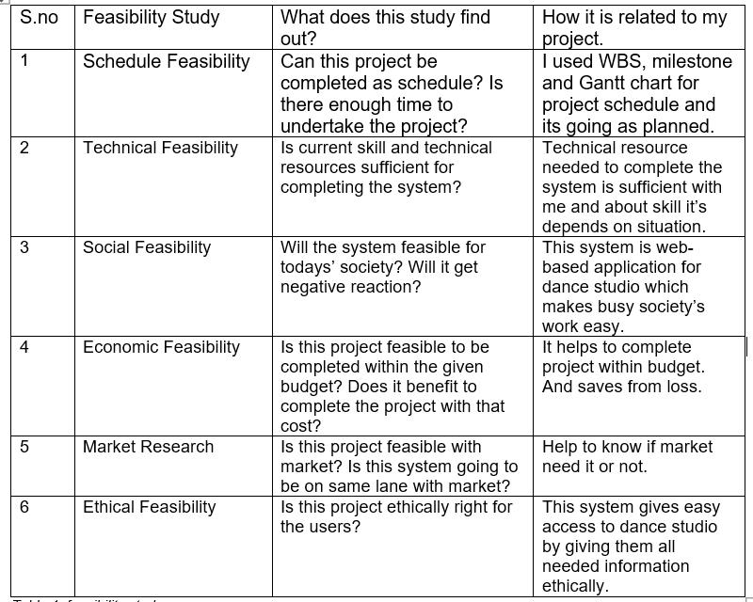

Table 1: feasibility study

## 2.4 Requirement Analysis

### 2.4.1 Functional Requirement

Functional requirements are concerned with system services such as the scope of the system, the necessary business functions and the required data structures.

The different types of functional requirement of system is given below in the table:

|  |  |  |  |  |
| --- | --- | --- | --- | --- |
| **S.no** | **Title** | **Description** | **Rational** | **Dependencies** |
| FR1 | Database Connection | It makes connection between system and database. | To handle user information. | N/A |
| FR2 | Registration | Registering new user for getting access to privilege. | To create an account. | FR1 |
| FR3 | Login | Function to let user to get access to the system. | To login to the system. | FR2 |
| FR4 | Authentication | Authentication is required to check if account is correct one. | To avoid unknown user to get access. | FR2 |
| FR5 | Add class | If there is some new class in studio are added then admin can add those classes in the system. | To add new class. | FR3 |
| FR6 | Delete class | If some of the existing class are going to be close then admin can remove those class from the system. | To remove class. | FR3 |
| FR7 | Edit profile | User can edit their profile information.  Change their information. | To edit profile. | FR3 |
| FR8 | Delete profile | User themselves can delete their profile if they are closing contact with the studio. | To delete profile. | FR3 |
| FR9 | Add events | Any new events that the studio is going to organize or participate in are posted here by admin. | To add events. | FR3 |
| FR10 | Edit events | Only admin can edit existing events from system. | To edit events | FR3 |
| FR11 | Delete events | Admin can delete events that are not needed. | To delete events | FR3 |
| FR12 | Post tickets | Tickets of events organize by studio are posted in the system by admin. | To post tickets. | FR3 |
| FR13 | Tickets booking | User can book events tickets from home. | For booking event tickets. | FR3 |
| FR14 | Class booking | User can book available dance class anytime they want. | To book dance class. | FR3 |
| FR14 | Cancel booking | User can cancel their class and tickets booking before class or events starting day. | To cancel tickets and class booking. | FR3 |
| FR15 | Payment | Users who books tickets and class pays for them with the help of payment function | To pay for booking of tickets and class. | FR3 |
| FR16 | Add user | Only admin can add other user in the system. | To add user. | FR3 |
| FR17 | Delete user | Only admin can delete other user from the system | To delete user accounts. | FR3 |
| FR18 | Advertise performance | Admin can advertise other user or another artists’ performance. | To advertise. | FR3 |
| FR19 | Queries | user who has login access can ask questions in this section. | To post question and answer. | FR3 |
| FR20 | Log out | User can logout when they finish their work. | To logout the account. | FR3 |

Table 2: functional requirements

### 2.4.2 Non- Functional Requirement

Whereas nonfunctional requirements deal with system constraints such as operation-how easy is it to use, performance and security, these are also known as supplementary requirements.

The different types of non-functional requirement of system is given below in the table:

|  |  |  |  |  |
| --- | --- | --- | --- | --- |
| **S.no** | **Title** | **Description** | **Rational** | **Dependencies** |
| NFR1 | Security | System should be secure by authentication method to secure data and information. | To secure data and information of users. | FR2 & FR3 |
| NFR2 | Performances | System should perform quick with better response time. | To make program run quick and smooth. | N/A |
| NFR3 | Availability | System should be available anytime user wants. | To ensure user can access the system anytime. | N/A |
| NFR4 | Privacy | System should be able to provide privacy. Privacy make system trustable. | To ensure user can feel safe. | N/A |
| NFR5 | Maintainability | System should be able to maintain itself and repair and replace faulty components. | To ascertain there will be not many errors. | N/A |
| NFR6 | Usability | System should be usable by user with effectiveness, efficiency, and satisfaction. | To make user satisfied. | N/A |
| NFR7 | Scalability | Increase in user shouldn’t be problem to system. It should work with ease even with more user. | To run system smoothly even with large number of users. | N/A |
| NFR8 | Reliability | System should perform consistently well. | To build trust. | N/A |
| NFR9 | Legal | System should be made within legal terms. So, it can operate in society. | System inside legal boundary keep problem away. | N/A |
| NFR10 | Capacity | System must be capable of storing large data effectively and inform before storage runs out of space. | To ensure system run efficiently. | N/A |

Table 3: non-functional requirements

### 2.4.3 MoSCoW Prioritization

MoSCoW prioritization is a popular prioritization technique use for managing requirements. This method is commonly used for making key stakeholders understand the significance of initiatives in a specific release.

There are four categories of MoSCoW and they are must have, should have, could have, and won’t have. Sometimes, “wish” is used in MoSCoW instead of “won’t have”.

* Must have

It describes those requirements that must be in the system. These requirements are non-negotiable. And without them project will fail.

* Should have

It describes the requirements which occupy second place in the priority list. It is important but not critical to launch but it has high value to users.

* Could have

This point describes requirements that are desirable but not necessary.

* Won’t have

This point describes the requirements which will not be implemented in current release but it may be included in future release.

The prioritization of different functional requirements of my project are shown in the table below.

|  |  |  |  |
| --- | --- | --- | --- |
| **ID** | **Title** | **MoSCoW** | **Remarks** |
| FR1 | Database Connection | Must have |  |
| FR2 | Registration | Must have |  |
| FR3 | Login | Must have |  |
| FR4 | Authentication | Must have |  |
| FR5 | Add class | Must have |  |
| FR6 | Delete class | Must have |  |
| FR7 | Edit profile | Must have |  |
| FR8 | Delete profile | Should have |  |
| FR9 | Add events | Must have |  |
| FR10 | Edit events | Could have |  |
| FR11 | Delete events | Must have |  |
| FR12 | Post tickets | Should have |  |
| FR13 | Tickets booking | Should have |  |
| FR14 | Class booking | Must have |  |
| FR14 | Cancel booking | Must have |  |
| FR15 | Payment | Should have |  |
| FR16 | Add user | Should have |  |
| FR17 | Delete user | Should have |  |
| FR18 | Advertise performance | Won’t have |  |
| FR19 | Queries | Should have |  |
| FR20 | Log out | Must have |  |

Table 4: MoSCoW Prioritization of functional requirements.

|  |  |  |  |
| --- | --- | --- | --- |
| **ID** | **Title** | **MoSCoW** | **Remarks** |
| NFR1 | Security | Must have |  |
| NFR2 | Performances | Should have |  |
| NFR3 | Availability | Should have |  |
| NFR4 | Privacy | Must have |  |
| NFR5 | Maintainability | Should have |  |
| NFR6 | Usability | Should have |  |
| NFR7 | Scalability | Must have |  |
| NFR8 | Reliability | Should have |  |
| NFR9 | Legal | Must have |  |
| NFR10 | Capacity | Should have |  |
| NFR1 | Security | Must have |  |

Table 5: MoSCoW Prioritization of non- functional requirements.

### 2.4.4 SRS (System Requirement Specification)

Hardware and software requirement specification are given below:

|  |  |
| --- | --- |
| **Hardware** | **Software** |
| * RAM: 2 GB minimum * Processor: core 2 duo and higher * Disk space: 400GB | * Operating system: Windows 7, 8, 10 * Browser: Mozilla Firefox, google chrome, opera. * Database: SQL |

Table 6: hardware and software specification

## 2.5 Use Case diagram

Use Case is a graphical representation of interaction between actor and system. It shows how user can work in system with following notations:

* Actor (user): stick man figure which represents user.
* System boundary: rectangle shape box.
* Use Case: it is in oval shape where actions that actor might perform.
* Associations: it is a line which shows relation between actor and use case.

Use case diagram of admin is given below:

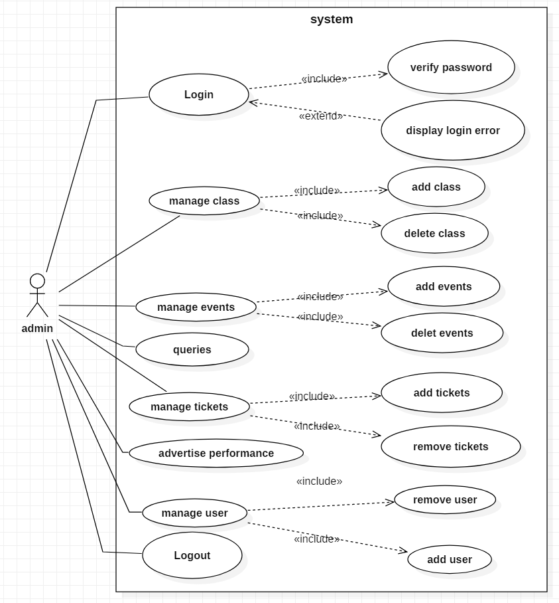

Figure 3: Use Case of admin

Description

Actor: Admin

Admin is a user who supervise the system with its super privilege. Admin can use following function:

* Admin can login to the system with correct id and password.
* Admin can manage classes like adding new class and deleting existing class.
* Admin can manage events like add events and delete events.
* Admin can use queries to ask question or give answer to questions.
* Admin can add tickets of events and remove tickets.
* Admin can advertise performance.
* If there is some user who needed to be added in the system or remove from the system then admin can do that.
* Admin can logout from the system so other can’t use the same id to misuse the privilege of admin.

Use case diagram of user is given below:

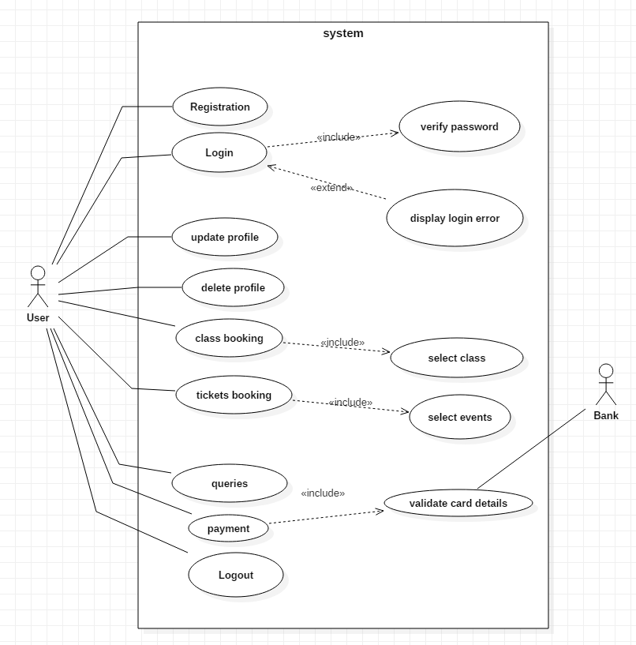

Figure 4: Use Case of user

Description

Actor: general user

General users are user for whom this system is made. They can perform following activities:

* Unregister user can register as new user in the system.
* User can login to the system after they register in the system.
* User has privilege to edit their own profile.
* If user is leaving studio, they can delete their profile.
* User can book classes they want to take part in.
* User can book events that they want to visit.
* Users can post question and answer in queries.
* User can logout from the system so, their account remains safe.

## 2.6 NLA & Initial Class Diagram

Dance studio is a dance school in Lalitpur which provide platform for learning and performing dance for children. Its been doing work like booking class, booking tickets of events, advertising events and performance manually. Now every company works digitally and it makes work easier and efficient so, Dance studio wants to develop the online website for themselves.

In this system there are two types of users with different access of function. They are admin and general user. General user needs to register into the system to get access to the functions of the website with information like name, address, phone, email, password, etc. with the access to system user must be able to view the class they want and book them to enroll in that class. With login access of general users, they can also update and delete their profile. Since there is event section so, general users can also book events tickets online. There is a queries section in which user can ask question or provide answer.

|  |  |  |
| --- | --- | --- |
| **Candidate Classes** | **Candidate Method** | **Candidate attribute** |
| users, class, events, tickets, payment | Book, register, view, add, delete, update | name, address, email, phone, password |

Initial Class Diagram is given below:

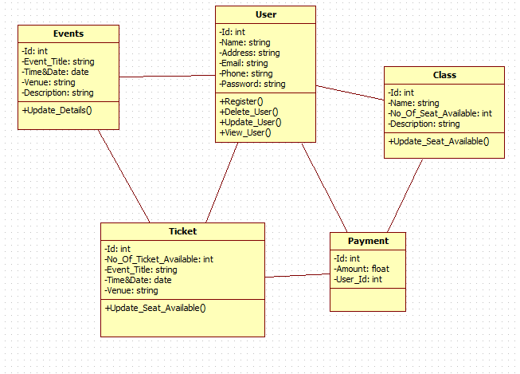

Figure 5: initial class diagram

# **CH-3 Design**

Design is the most crucial phase in the development of a system. Logical design is formed in analysis phase and converted into physical design in this phase. In the design phase the SDLC process continues to move from the what questions of the analysis phase to the how*.* A detailed description of what is needed to solve original problem. Input, output, databases, forms, codification schemes and processing specifications are drawn up in detail. In the design stage, the programming language and the hardware and software platform in which the new system will run are also decided.

There are several tools and techniques used for describing the system design of the system. These tools and techniques are: Class diagram, Flow chart, Data flow diagram (DFD), Data dictionary, Decision table and Decision tree.

# **3.1 Structural modelling**

## **3.1.1 Class diagram**

Class diagram main building block in object-oriented modeling. They are used to show the different object in a system, their attributes, their operations and the relationships among them

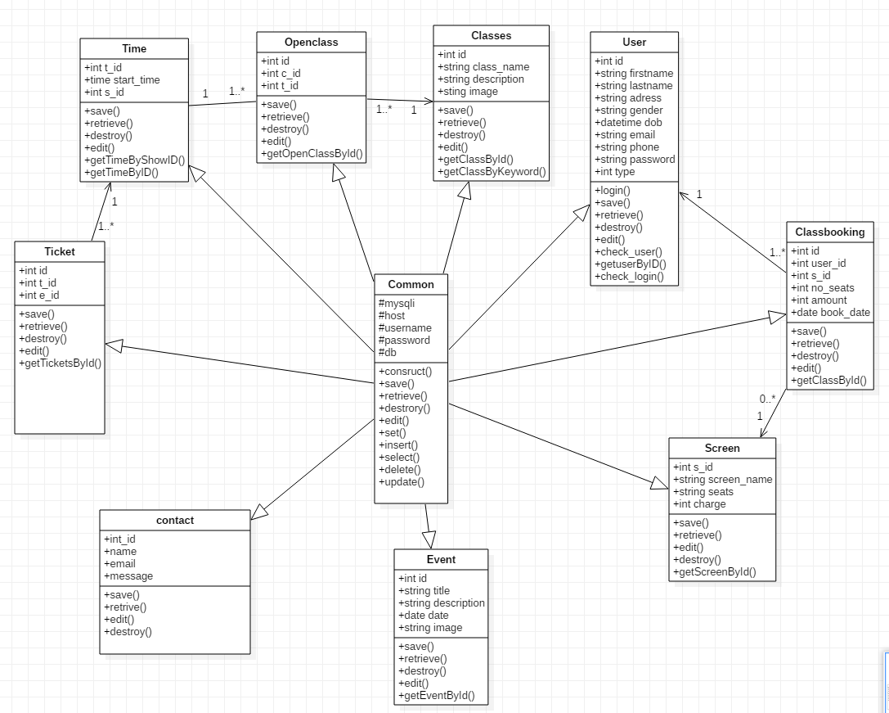

Figure 6 class diagram

## **3.1.2 Flow chart**

Flow chat is a pictorial representation which shows the flow of process which helps in understanding the flow in which system works.

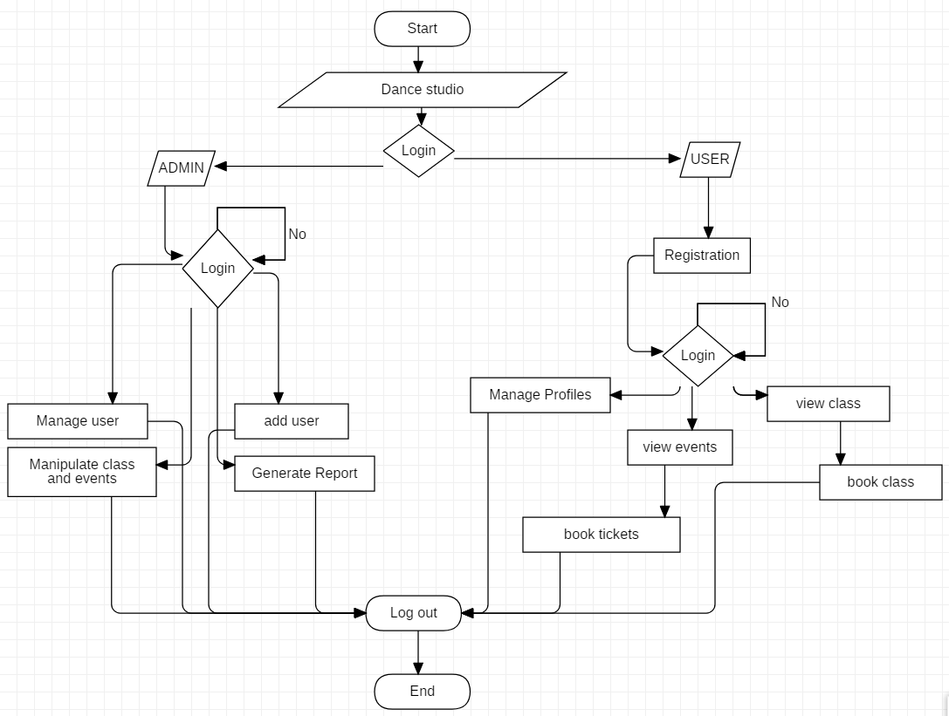

Figure 7 flow chart

Above given picture is the flowchart design for this project which show the flow of process in which user will operate the system. At first login for two type of user admin and general user. They have their own accessible function for themselves.

# **3.2 Behavior modelling**

## **3.2.1 Activity diagram**

Activity diagram is basically a flowchart to represent the flow of one activity to another activity.

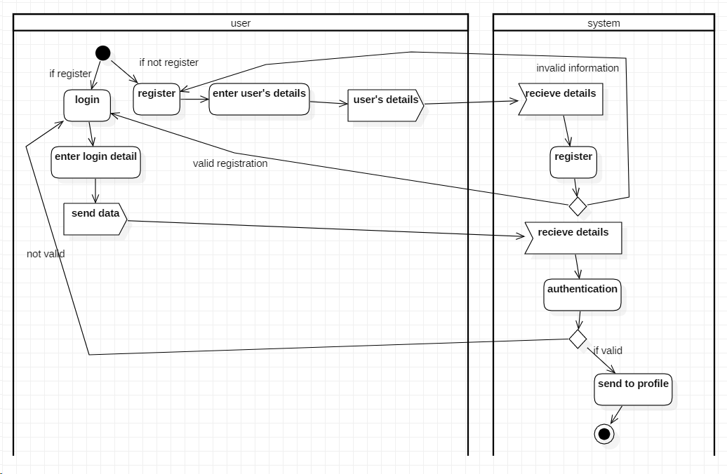

Figure 8 Activity diagram of login and register system

Above activity diagram show login and register system of the project. It means user need to get login to use some functions. It shows that user need to login into the system if they don’t have account in the system, they will require to register their account.

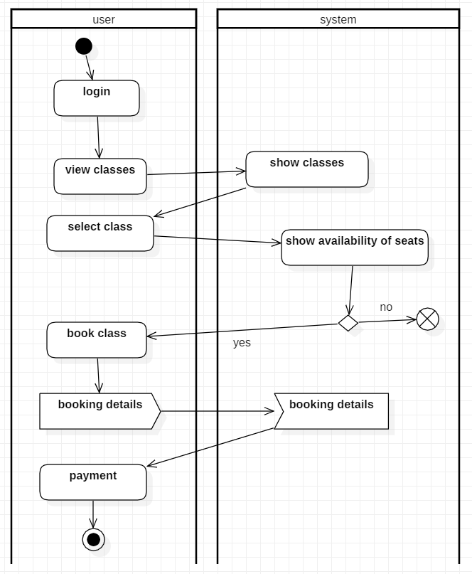

Figure 9 Activity diagram of class booking system

Above activity diagram show the activity process on booking dance class. Only login user can use this function. At first, user need to be logged in the system then they will view class after choosing class they check for seats availability of that class if seats are not available process gets terminate else they will book class.

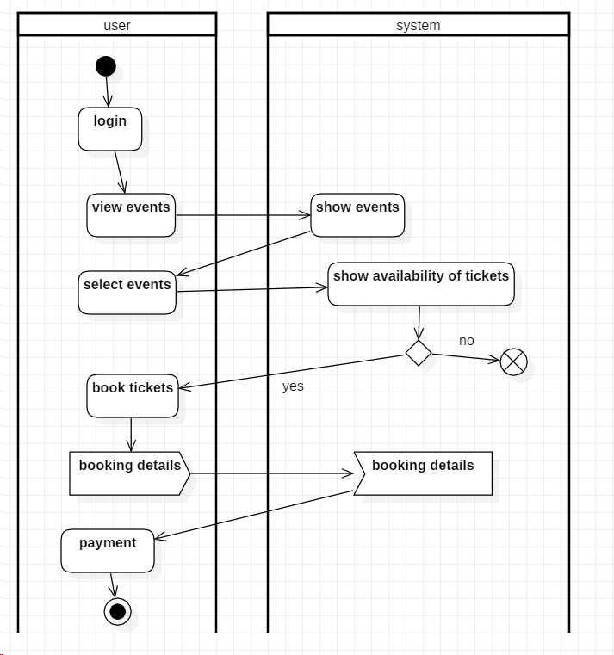

Figure 10 Activity diagram of events booking system

Above activity diagram show the activity process on booking tickets of events. Only login user can use this function. At first, user need to be logged in the system then they will view events after choosing events they will checks if tickets are available or not for this events if tickets are not available process gets terminate else they will book class by submitting some booking details.

## **3.2.2 Sequence diagram**

A sequence diagram is a pictorial representation of object interactions arranged in time sequence. It shows the objects and classes involved in the scenario and sequence of message exchanged between the object.

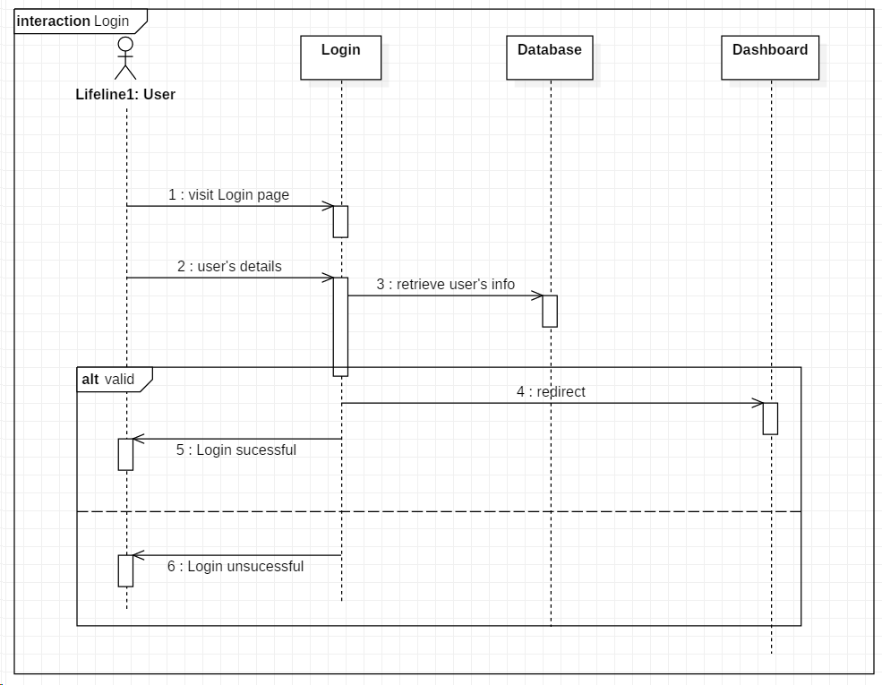

Figure 11 Sequence diagram of login and register system

Above given diagram is login sequence diagram. Its checks authentication of user by asking some user information like email and password. If the information given by user is correct then they will get access to system else get redirect to failed page.

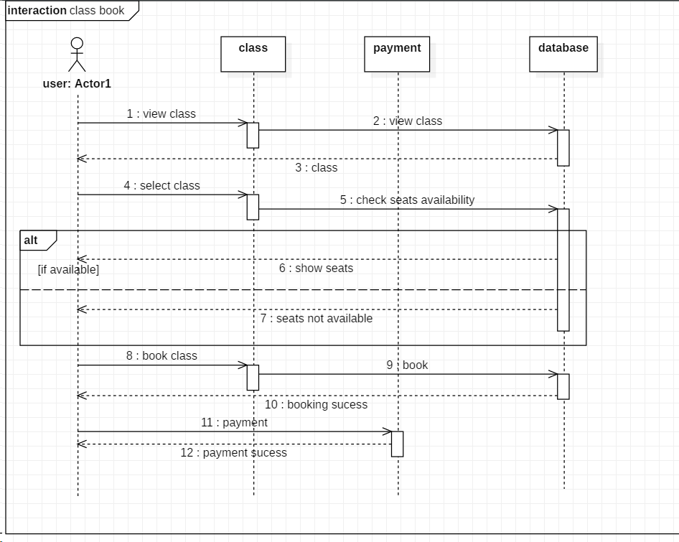

Figure 12 Sequence diagram of class booking system

This sequence diagram shows the flow in which dance class is booked. User asks for class information from database and decide to either book the class or not then if they want to book the class, they will do payment.

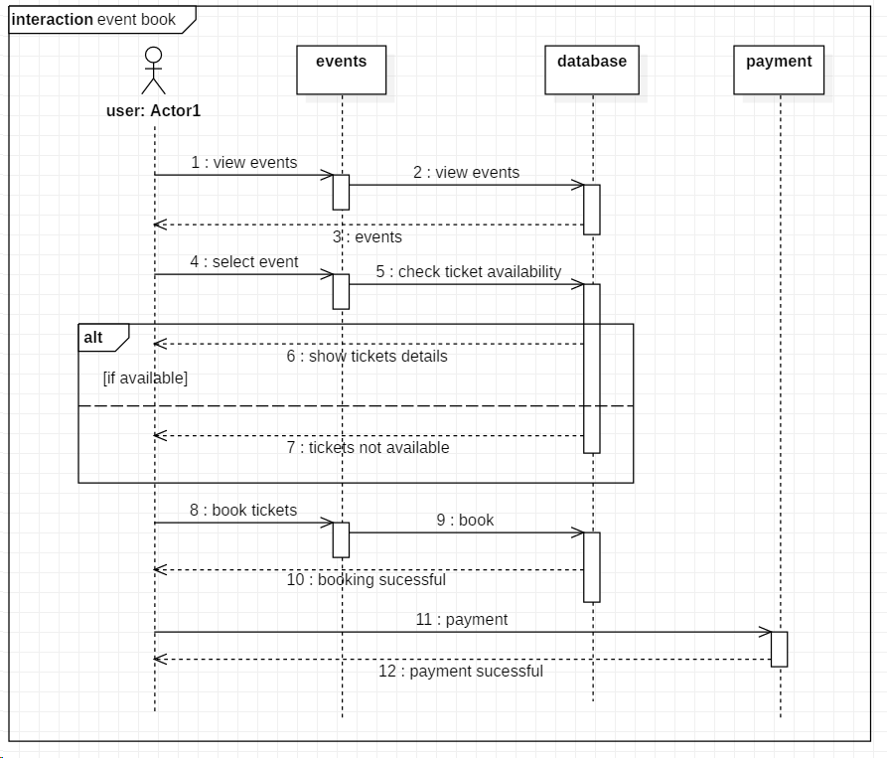

Figure 13 Sequence diagram of events booking system

This sequence diagram shows the flow in which events’ tickets is booked. User asks for events’ information from database and decide to either book the tickets or not then if they want to book the tickets, they will do payment.

# **3.3 Database modelling**

## **3.3.1 Data dictionary**

The table containing with many sets of information that explains how database is designed is known as data dictionary. It consists of contents like names, functions of data elements and their explanation, etc.

|  |  |  |  |  |  |
| --- | --- | --- | --- | --- | --- |
| **Column** | **Data type** | **Length** | **Constraint** | **Nullable** | **Key** |
| user_id | Integer(10) | 10 | pk_user_id | No | primary |
| first_name | Varchar(200) | 200 | - | No | - |
| last_name | Varchar(200) | 200 | - | No | - |
| address | Varchar(200) | 200 | - | No | - |
| gender | Varchar(10) | 10 | - | No | - |
| dob | date | - | - | No | - |
| email | Varchar(200) | 200 | - | No | - |
| phone | Varchar(200) | 200 | - | No | - |
| password | Varchar(200) | 200 | - | No | - |
| type | char(10) | 10 | - | No | - |

Table 7 Data dictionary of user table

|  |  |  |  |  |  |
| --- | --- | --- | --- | --- | --- |
| **Column** | **Data type** | **Length** | **Constraint** | **Nullable** | **Key** |
| id | integer | 10 | pk_class_id | No | Primary |
| class_name | varchar | 50 | - | No | - |
| description | varchar | 1000 | - | No | - |
| image | varchar | 250 | - | No | - |

Table 8 Data dictionary class table

|  |  |  |  |  |  |
| --- | --- | --- | --- | --- | --- |
| **Column** | **Data type** | **Length** | **Constraint** | **Nullable** | **Key** |
| e_id | integer | 10 | pk_events_id | No | Primary |
| title | varchar | 50 | - | No | - |
| description | varchar | 1000 | - | No | - |
| date | date | - | - | No | - |
| image | varchar | 255 | - | No | - |

Table 9 Data dictionary of events table

|  |  |  |  |  |  |
| --- | --- | --- | --- | --- | --- |
| **Column** | **Data type** | **Length** | **Constraint** | **Nullable** | **Key** |
| ti_id | integer | 10 | pk_tickets_id | No | primary |
| t_id | integer | 10 | fk_time_id | yes | foreign |
| e_id | integer | 10 | fk_events_id | No | foreign |

Table 10 Data dictionary of tickets table

|  |  |  |  |  |  |
| --- | --- | --- | --- | --- | --- |
| **Column** | **Data type** | **Length** | **Constraint** | **Nullable** | **Key** |
| id | Integer | 10 | Pk_class_booking_id | No | primary |
| t_id | integer | 10 | fk_user_id | No | foreign |
| c_id | integer | 10 | fk_class_id | No | foreign |

Table 11 Data dictionary of open_class table

|  |  |  |  |  |  |
| --- | --- | --- | --- | --- | --- |
| **Column** | **Data type** | **Length** | **Constraint** | **Nullable** | **Key** |
| eb_id | integer | 10 | pk_tickets_booking_id | No | primary |
| user_id | integer | 10 | fk_user_id | No | foreign |
| s_id | integer | 10 | fk_screen_id | No | foreign |
| no_seats | int | 10 | - | No | - |
| book_date | date | - | - | No | - |
| amount | int | 10 | - | No | - |

Table 12 Data dictionary of events booking table

|  |  |  |  |  |  |
| --- | --- | --- | --- | --- | --- |
| **Column** | **Data type** | **Length** | **Constraint** | **Nullable** | **Key** |
| s_id | integer | 10 | pk_screen_id | No | primary |
| screen_name | varchar | 20 | - | No | - |
| seats | int | 10 | - | No | - |
| charge | int | 10 | - | No | - |

Table 13 Data dictionary of screen table

|  |  |  |  |  |  |
| --- | --- | --- | --- | --- | --- |
| **Column** | **Data type** | **Length** | **Constraint** | **Nullable** | **Key** |
| t_id | integer | 10 | pk_time_id | No | primary |
| start_time | time | - | - | No | primary |
| s_id | integer | 10 | fk_screen_id | No | foreign |

Table 14 Data dictionary of time table

|  |  |  |  |  |  |
| --- | --- | --- | --- | --- | --- |
| **Column** | **Data type** | **Length** | **Constraint** | **Nullable** | **Key** |
| id | integer | 10 | pk_class_booking_id | No | primary |
| user_id | integer | 10 | fk_user_id | No | foreign |
| s_id | integer | 10 | fk_screen_id | No | foreign |
| no_seats | int | 10 | - | No | - |
| book_date | date | - | - | No | - |
| amount | int | 10 | - | No | - |

Table 15 Data dictionary of class booking table

## **3.3.2 ER-Diagram**

Entity-relationship (ER) diagram is a graphical representation of entities and their relationship with each other, typically used in database or information system.

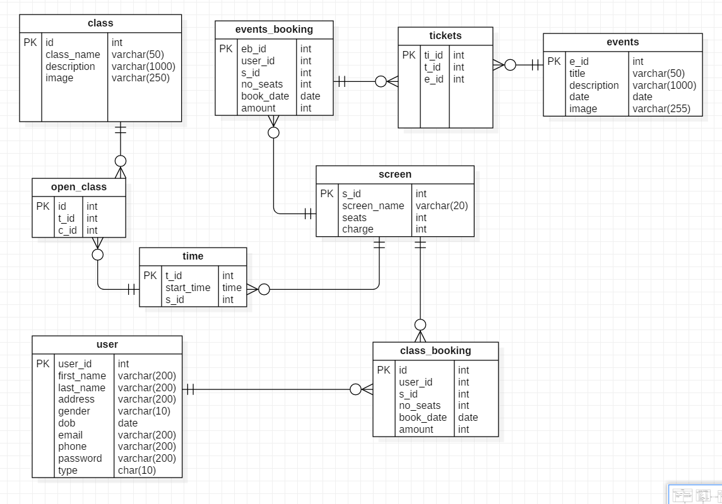

Figure 14 ER-Diagram

Above presented ER-diagram is designed based on data dictionary given prior to this design. Here the entities are shown along with the relationship that they have with each other.

# **3.4 Architectural Model**

For network architecture I am using client server architecture. Client server architecture is a network architecture in which each computer on the network is either a client or a server. Clients rely on servers for resources.

Because of the following reasons I have chosen client server architecture:

* More secure
* Data integrity
* Scalability
* High performance
* Easy maintenance and modification.

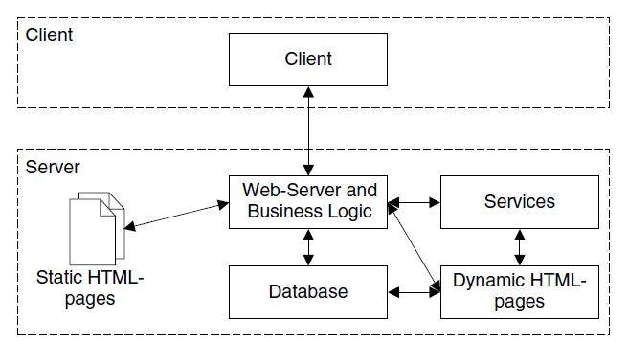

Figure 15 Architectural Model

# **3.5 Prototype design**

Prototype design is a way of presenting your idea in a buildable blueprint. It is an early sample or model of a product built.

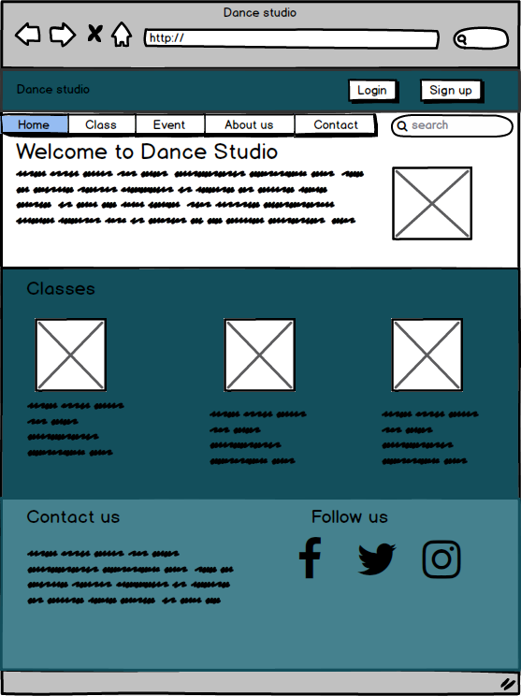

Figure 16 Prototype of home page

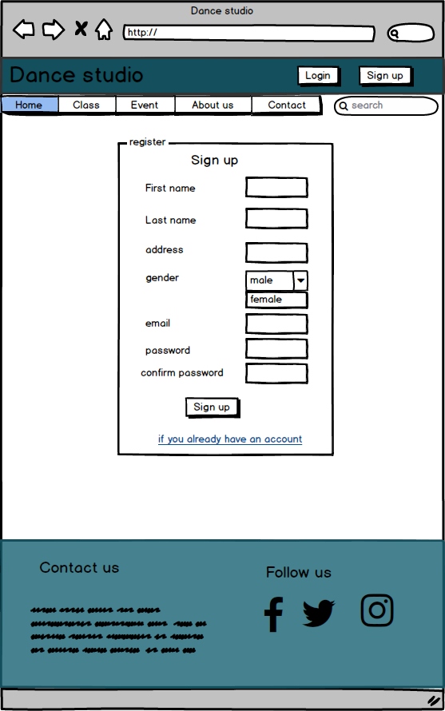

Figure 17 Prototype of register

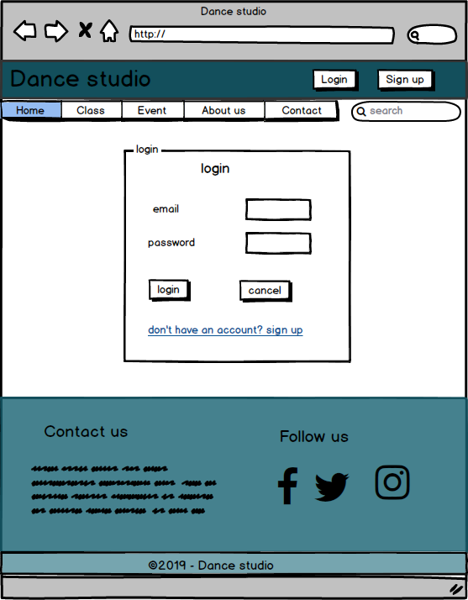

Figure 18 Prototype of login

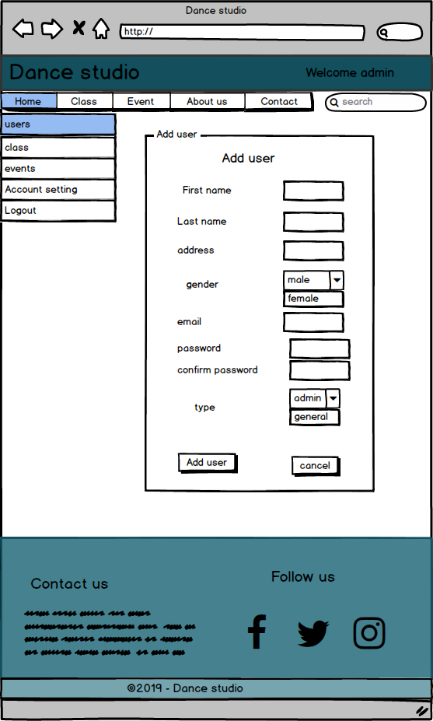

Figure 19 Prototype of add user

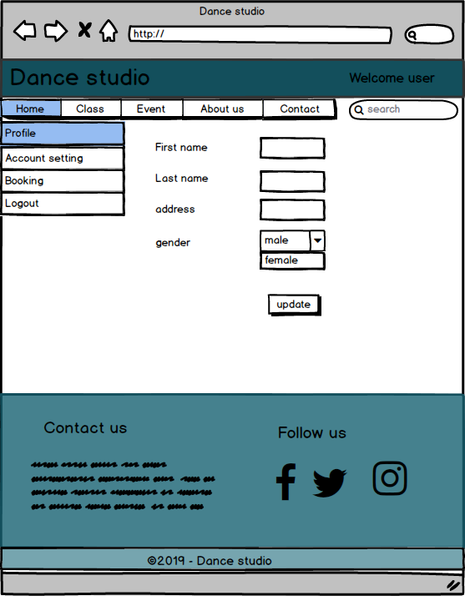

Figure 20 Prototype of profile

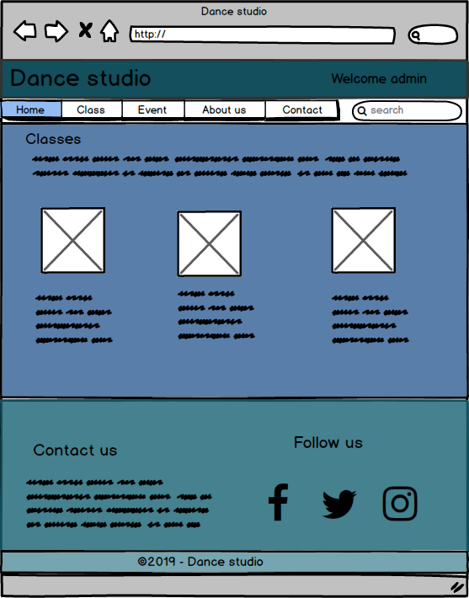

Figure 21 Prototype of admin page

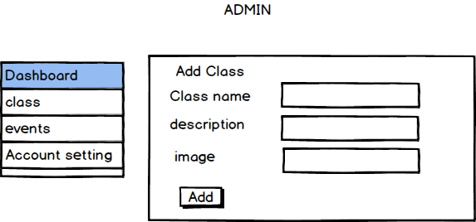

Figure 22 Prototype of add class

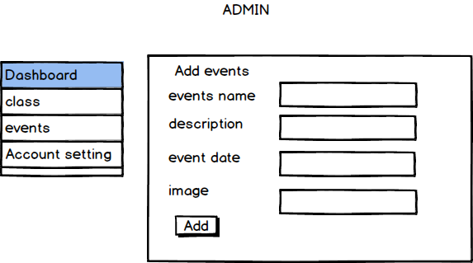

Figure 23 Prototype of add events

# **Chapter 4: Implementation (Coding)**

## **Introduction**

This phase of software development life cycle is the 3rd phase of SDLC process. First phase of SDLC process is requirement gathering after gathering the requirement project team starts to design the software then the project team uses that design to start the implementation phase.

In this phase developer creates actual product. Here ideas of user’s or customer’s get real and I have used MVC design pattern for this project.

## **4.1 Importance of coding**

* Code is the set of instruction that tells application what to do.
* Coding give tangible form to idea.

## **4.2 Tools Used**

In this implementation and coding phase, I used following tools:

* For running server, I used XAMPP
* For database, I used MY SQL
* Sublime text for coding.

## **4.3 Language Used**

Programming Language used in this project is Object Oriented PHP (Hypertext Pre-processor). PHP is a server-side scripting language that is used to develop the Web application.

## **4.4 Codes**

Home Page

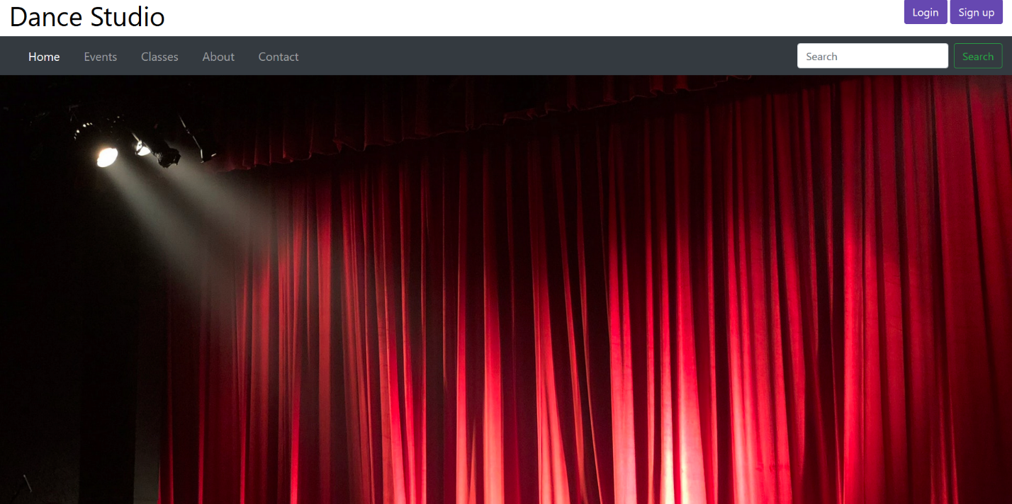

Figure 24 home page

Register

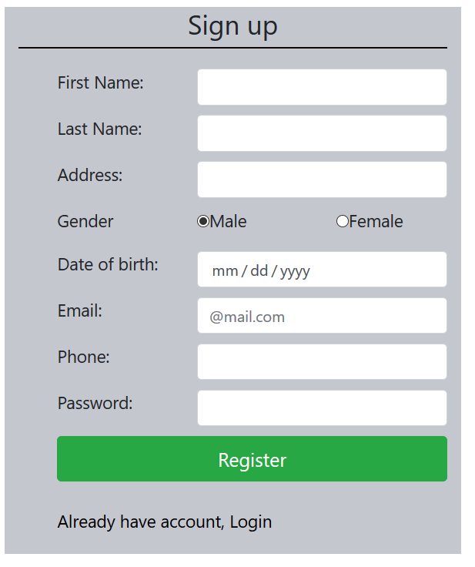

Figure 25 register

Codes of register:

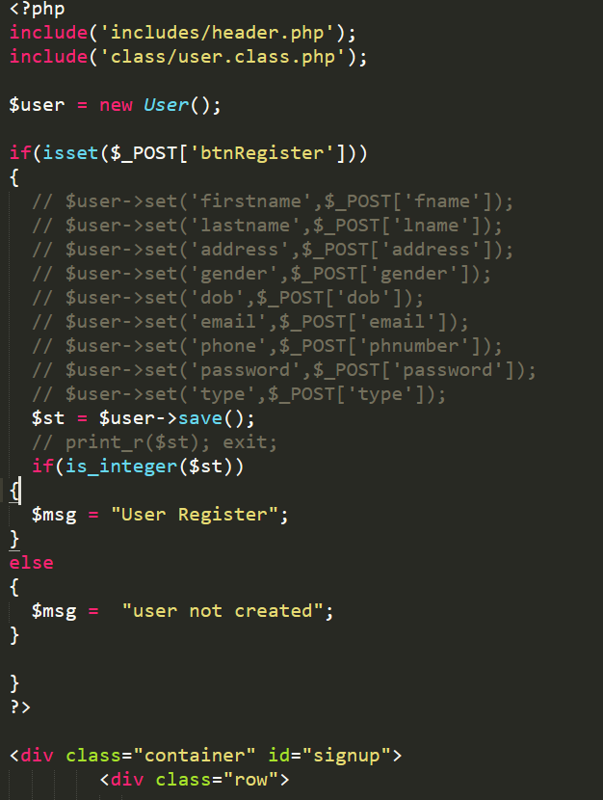

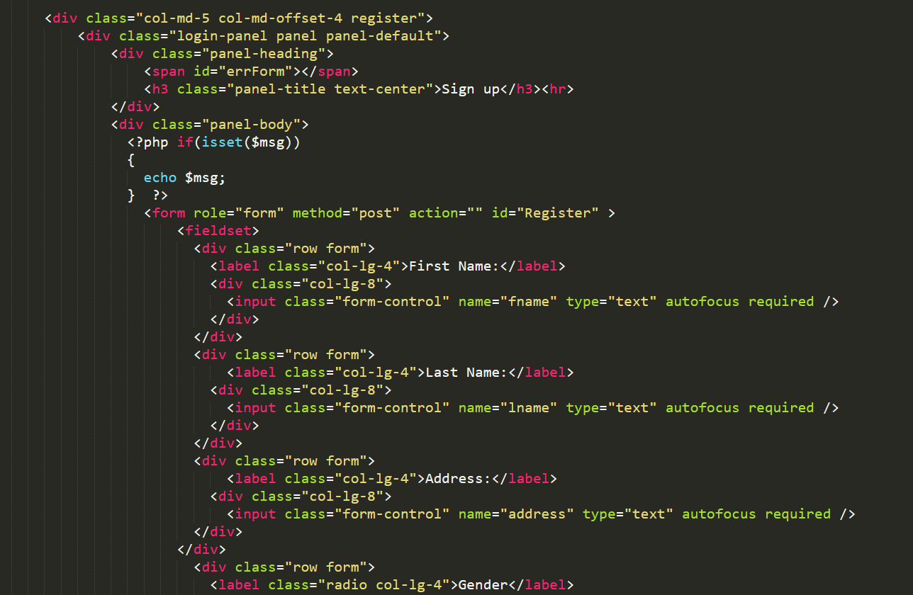

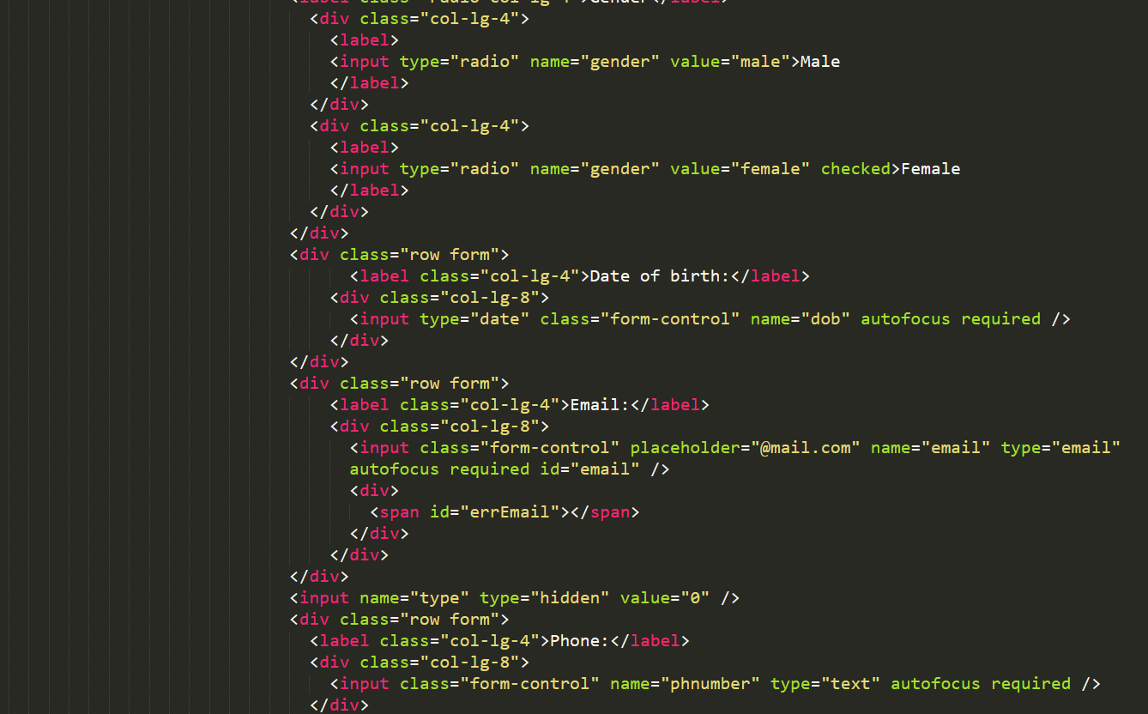

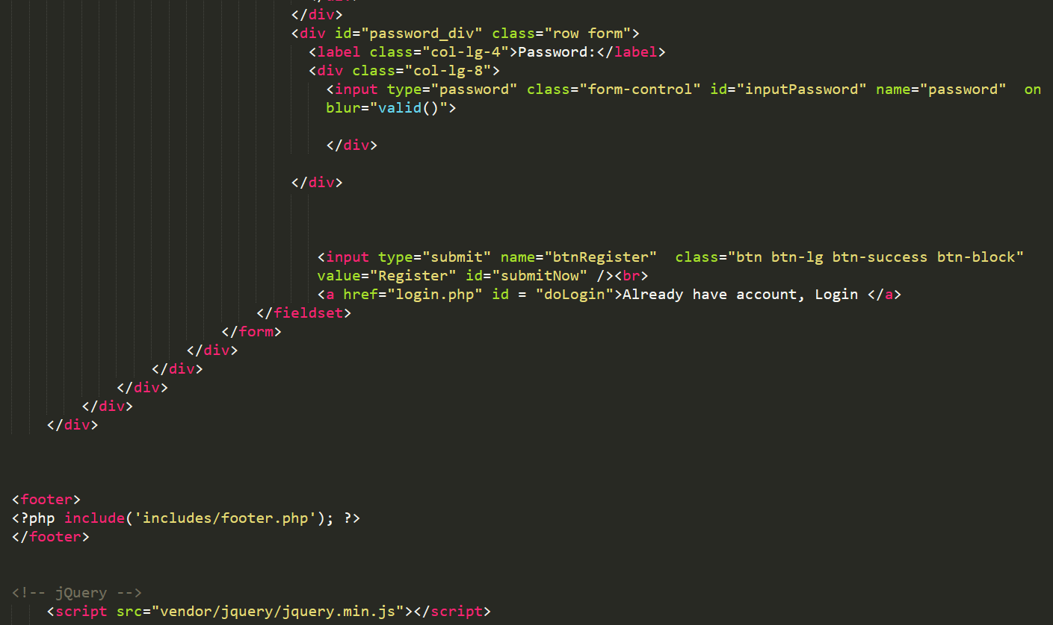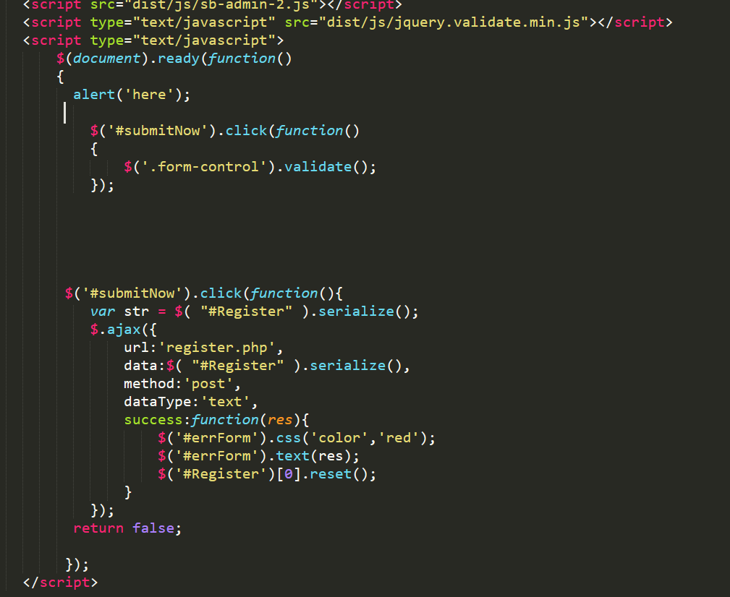

Figure 26 codes of register

Login:

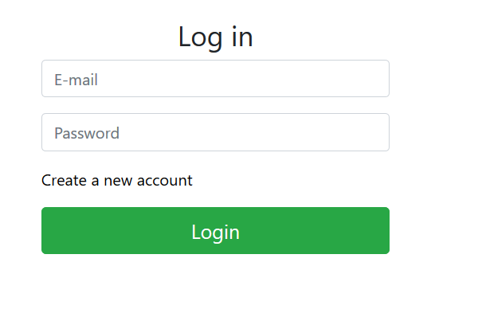

Figure 27 Login form

Codes of login:

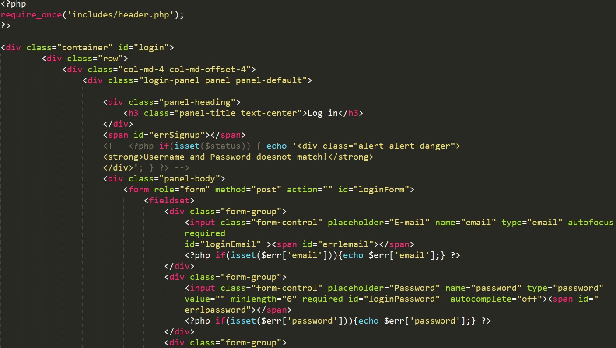

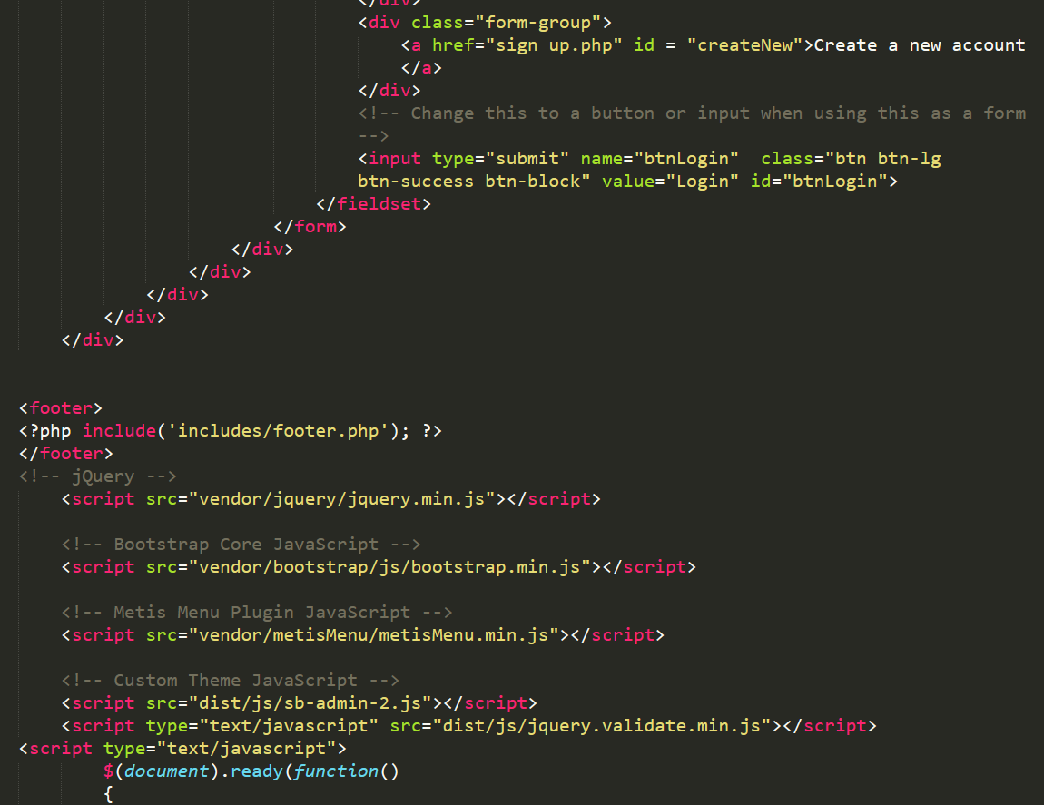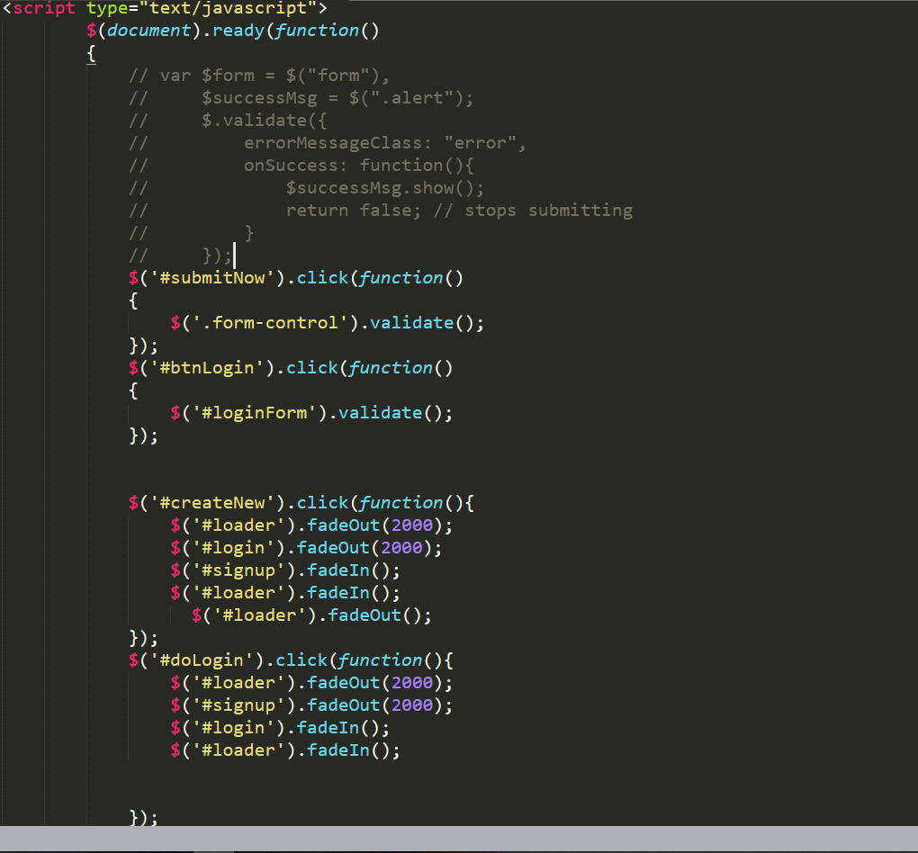

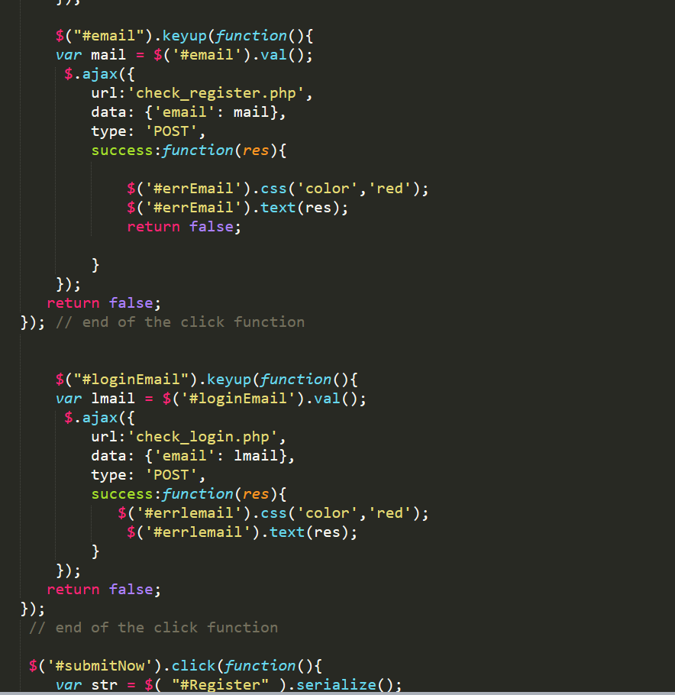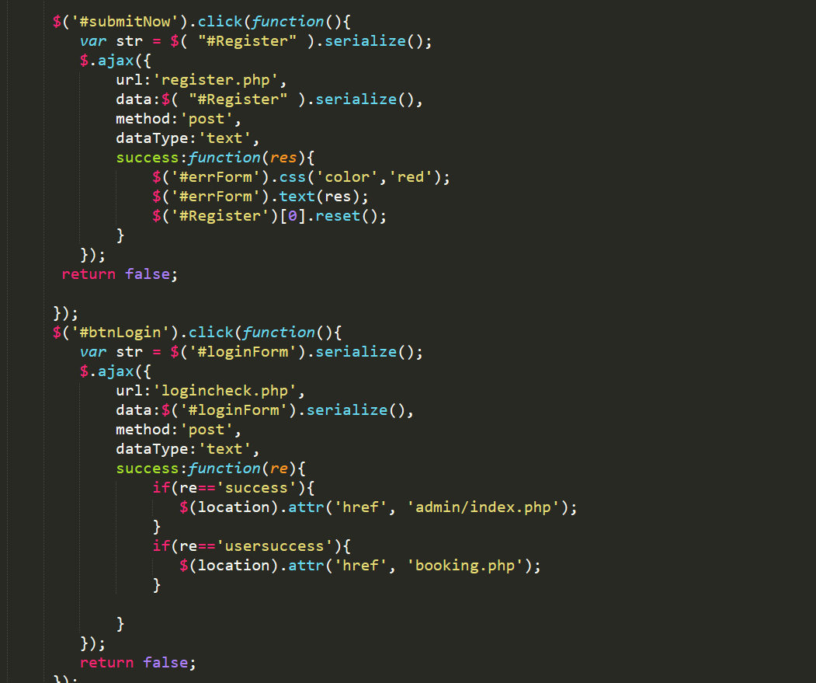

Figure 28 codes of login

Admin dashboard:

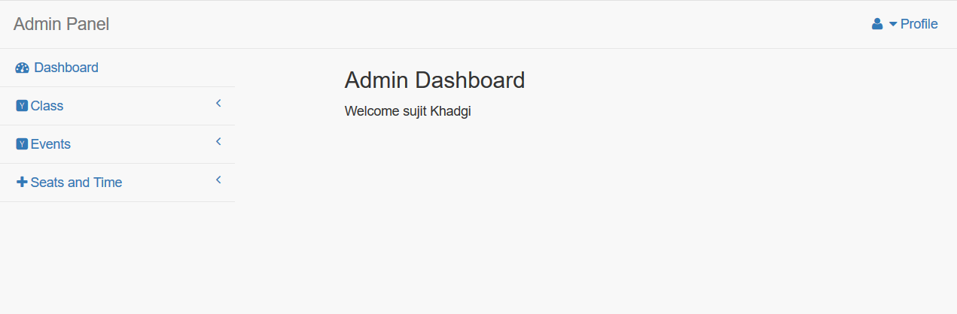

Figure 29 admin dashboard

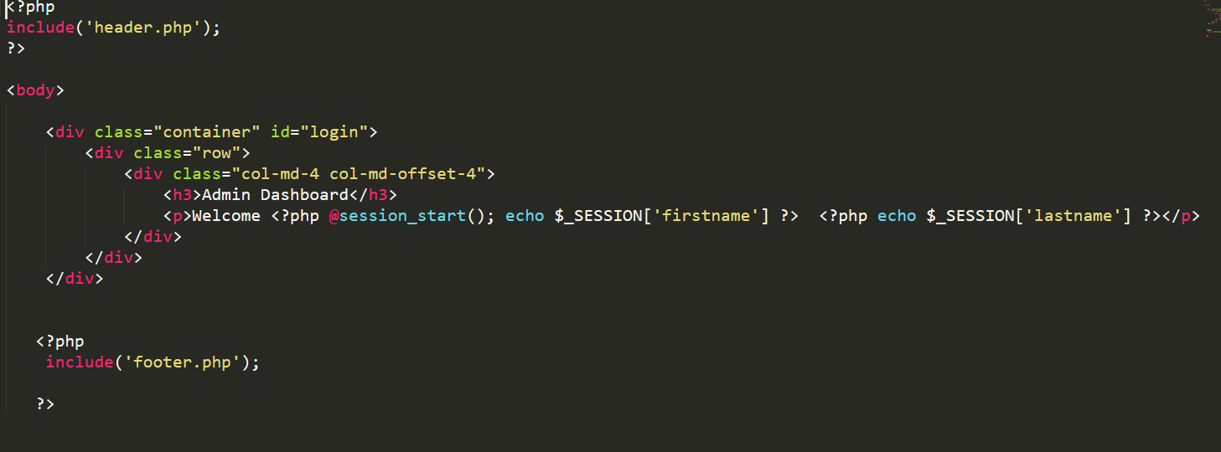

Figure 30 codes of admin dashboard

Add Class:

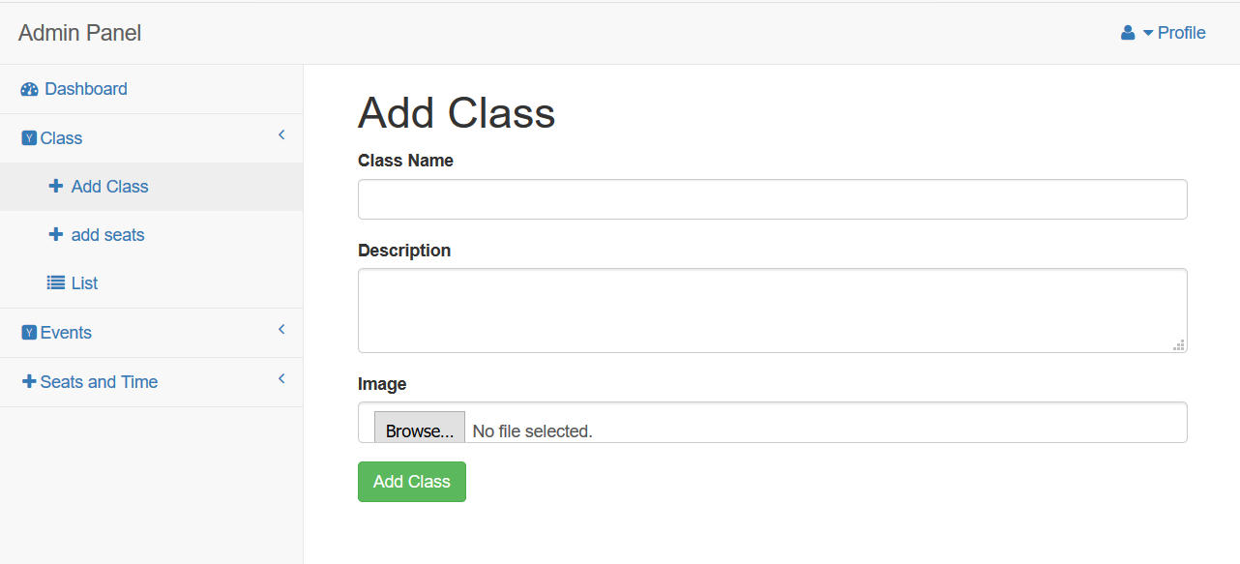

Figure 31 add class

Codes of add class:

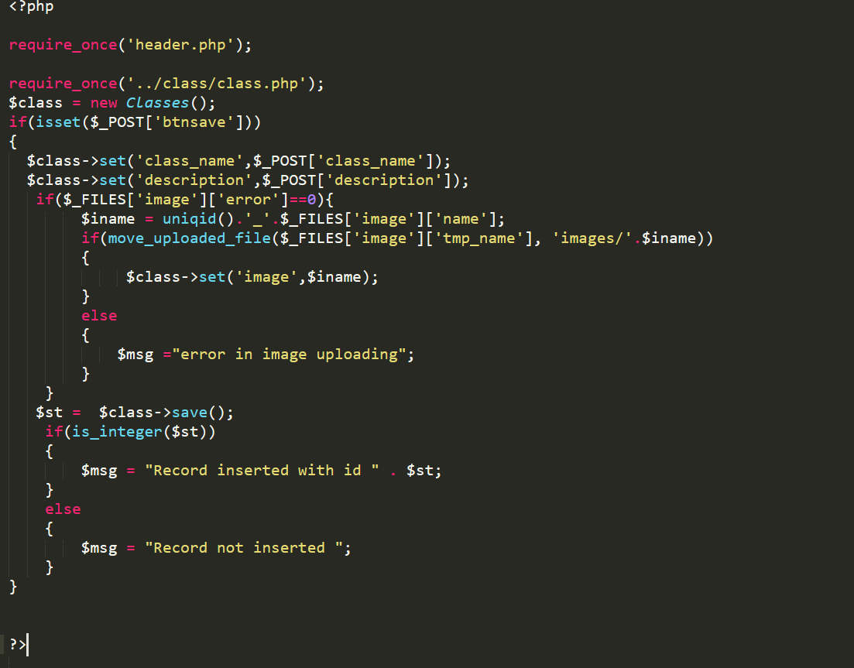

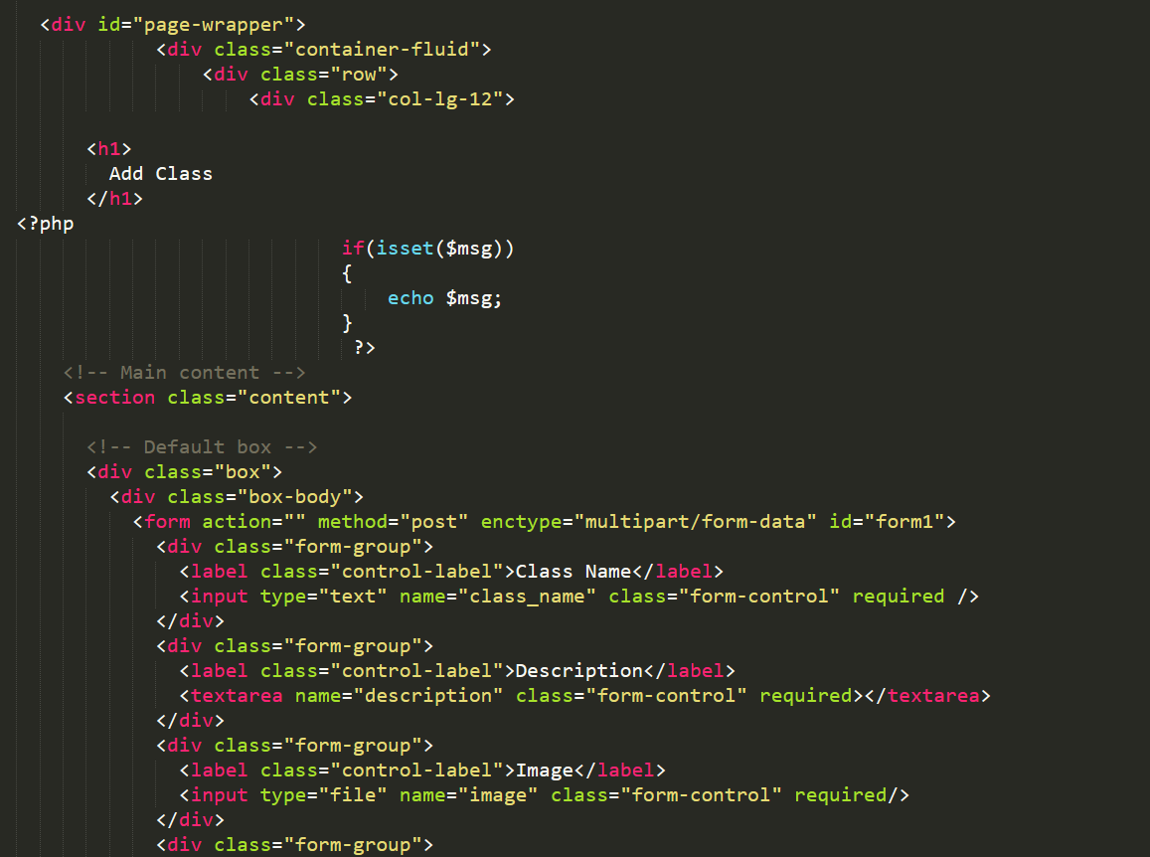

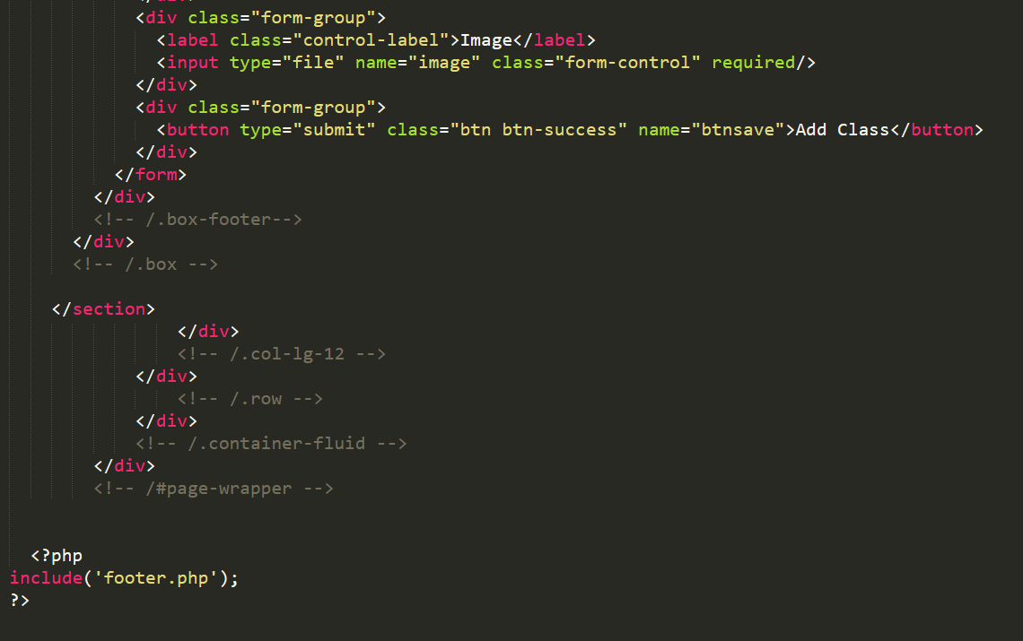

Figure 32 codes of add class

Add seats:

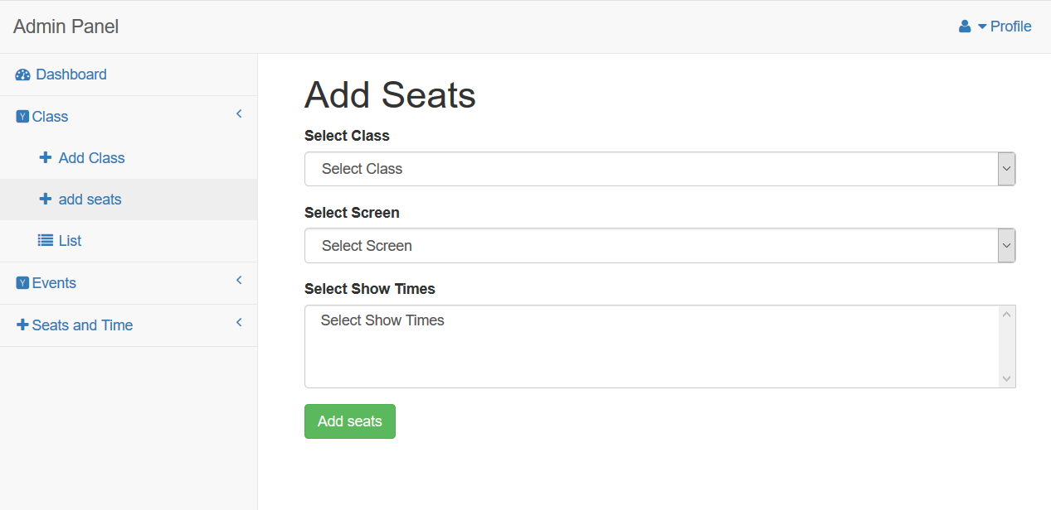

Figure 33 Add seats

Codes of Add seats:

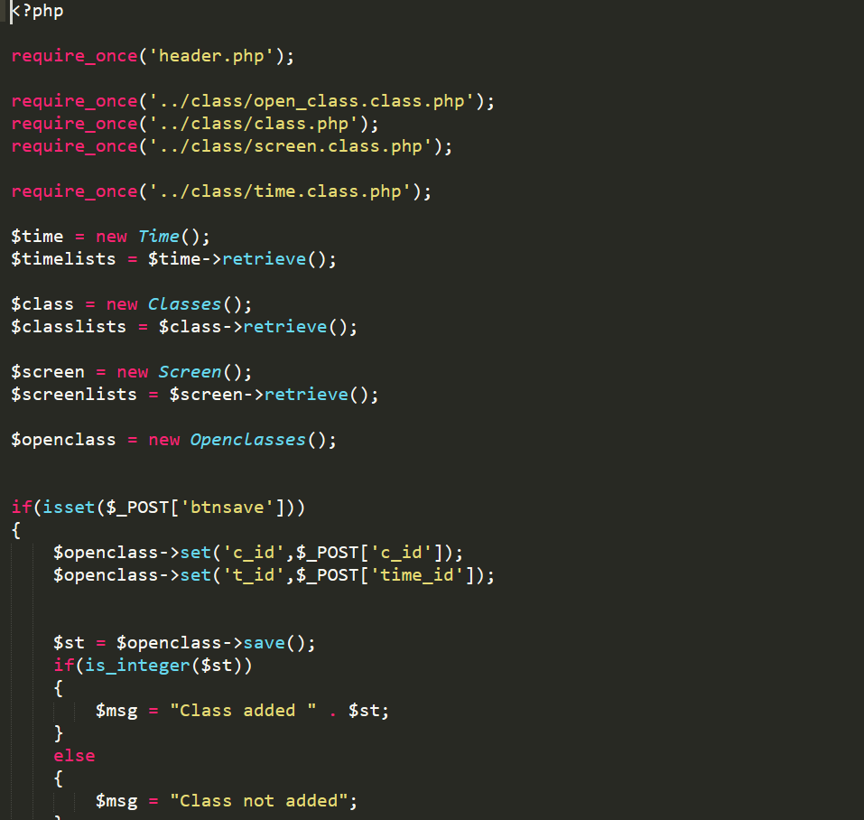

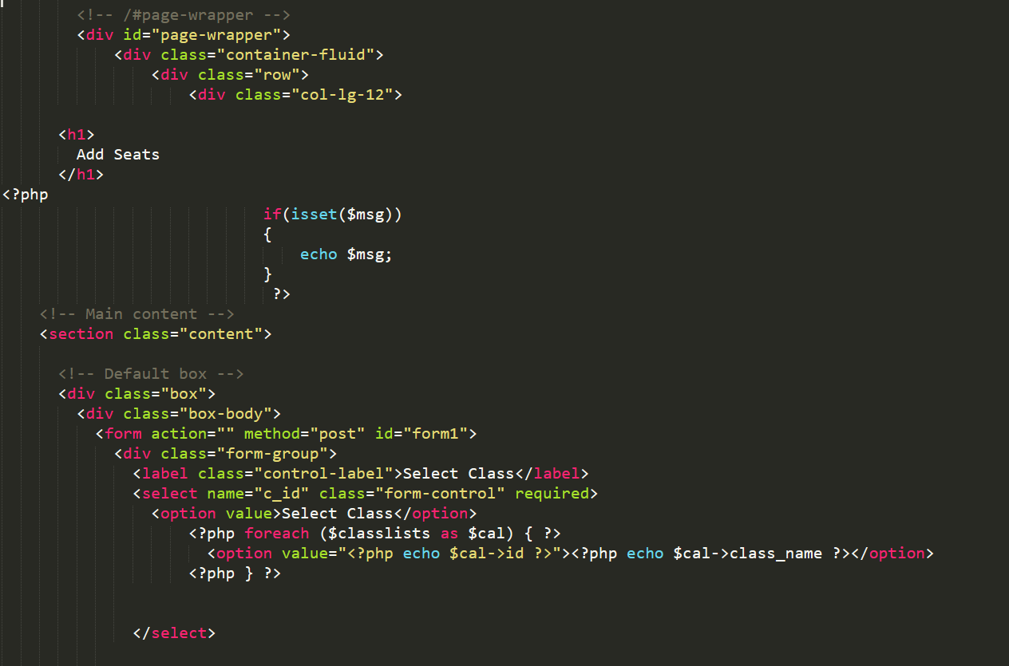

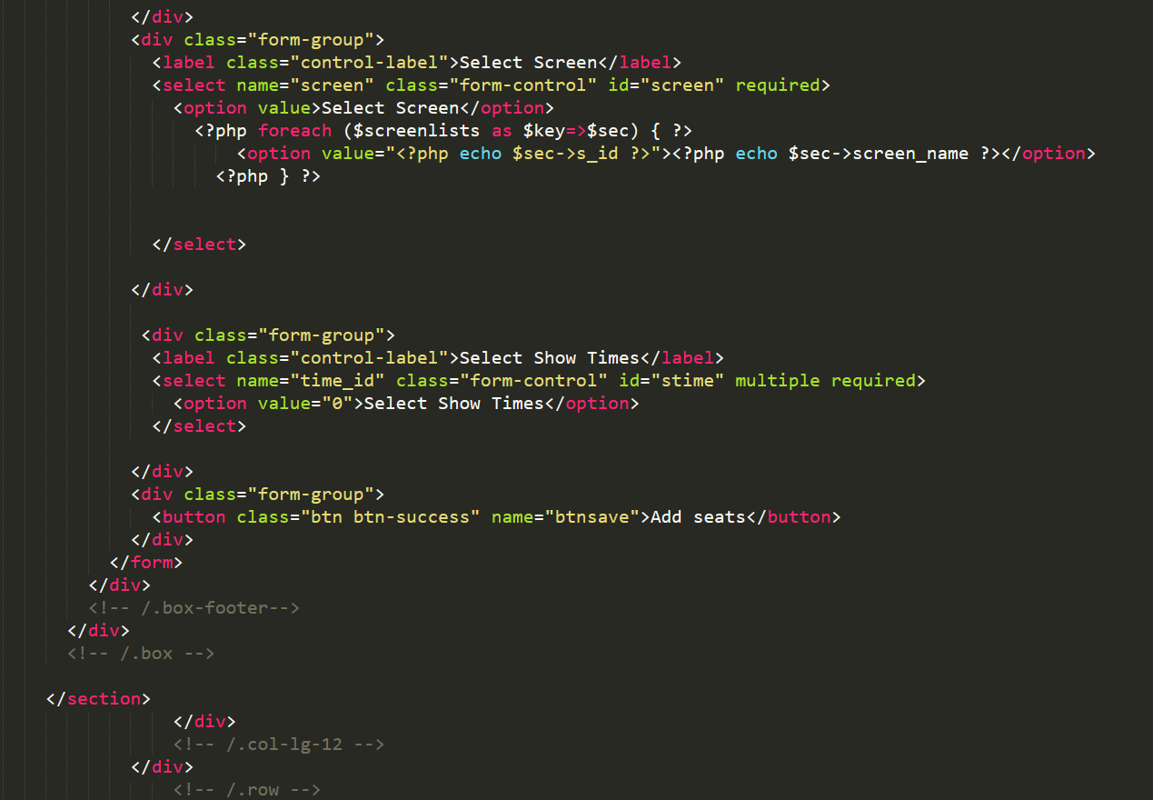

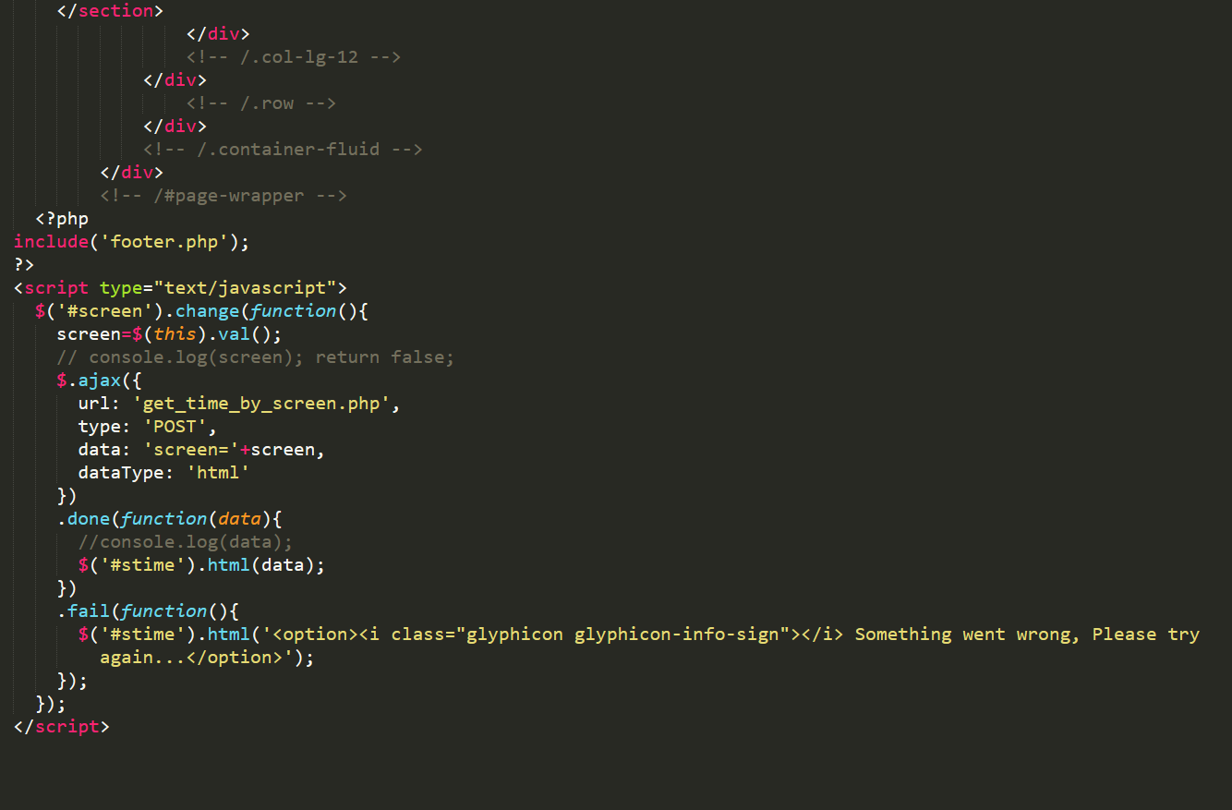

Figure 34 Codes of Add seats

Add events:

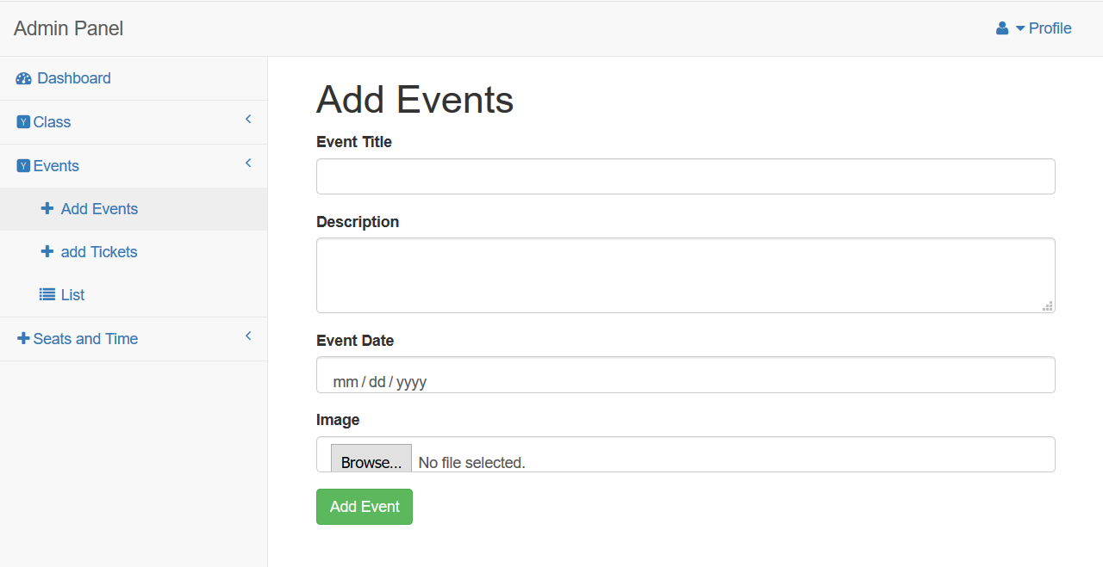

Figure 35 Add events

Codes of Add events:

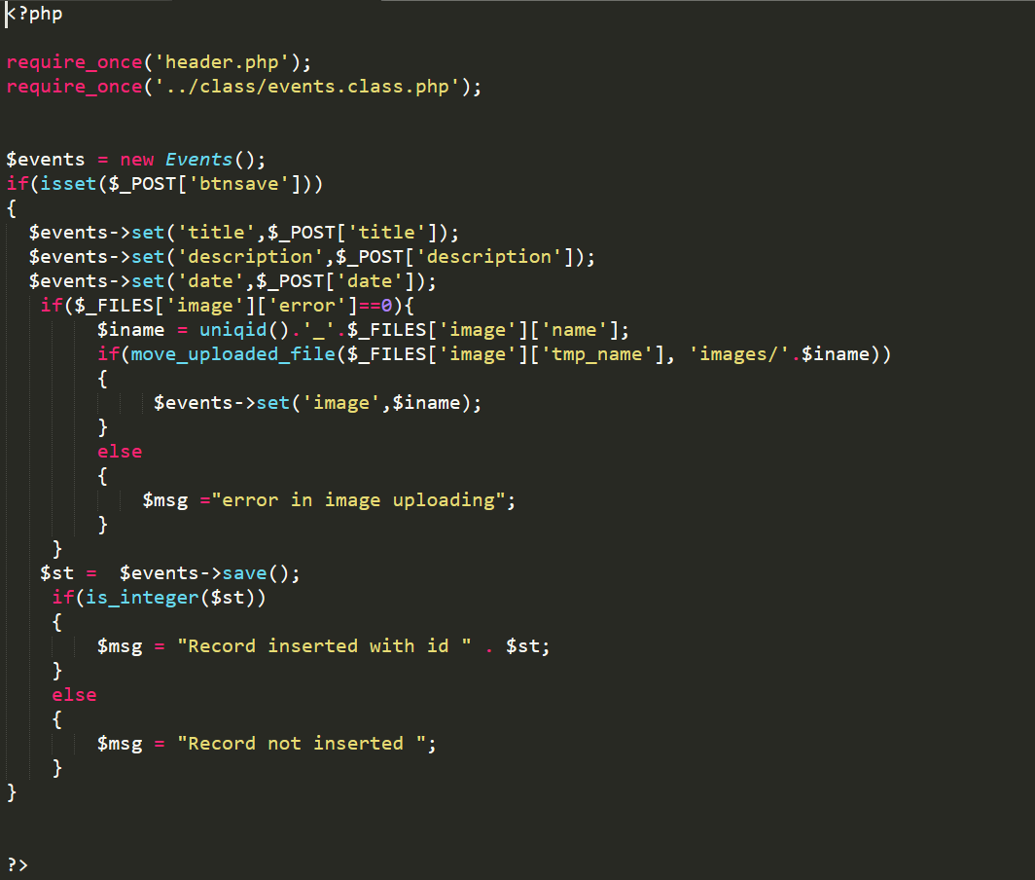

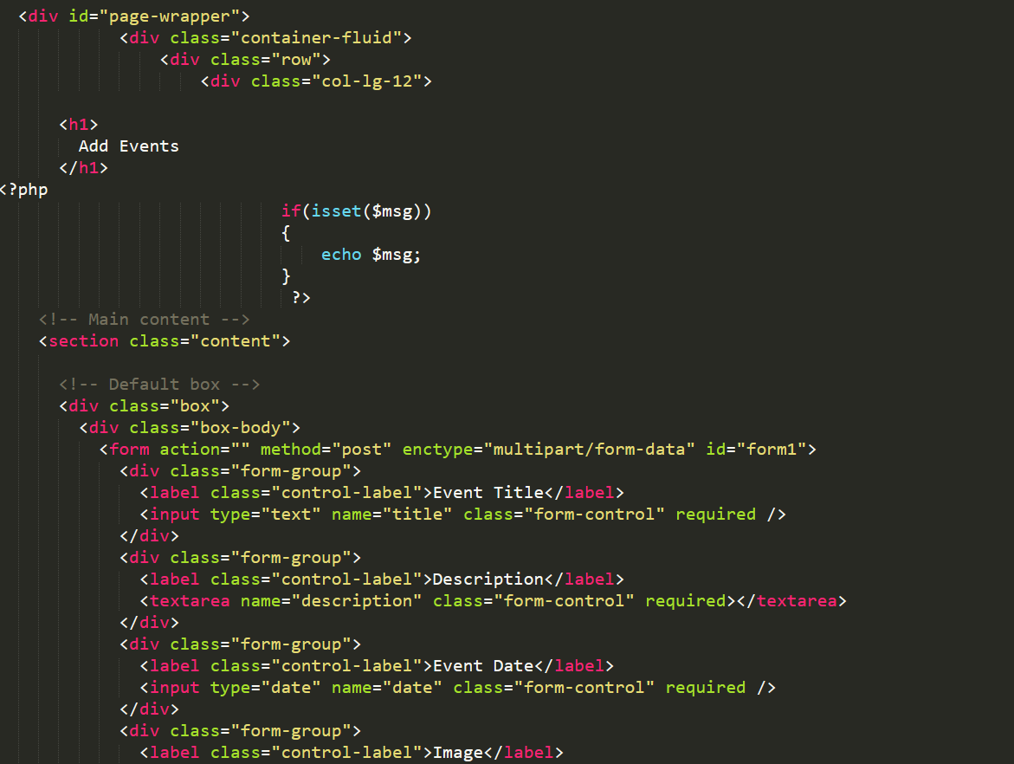

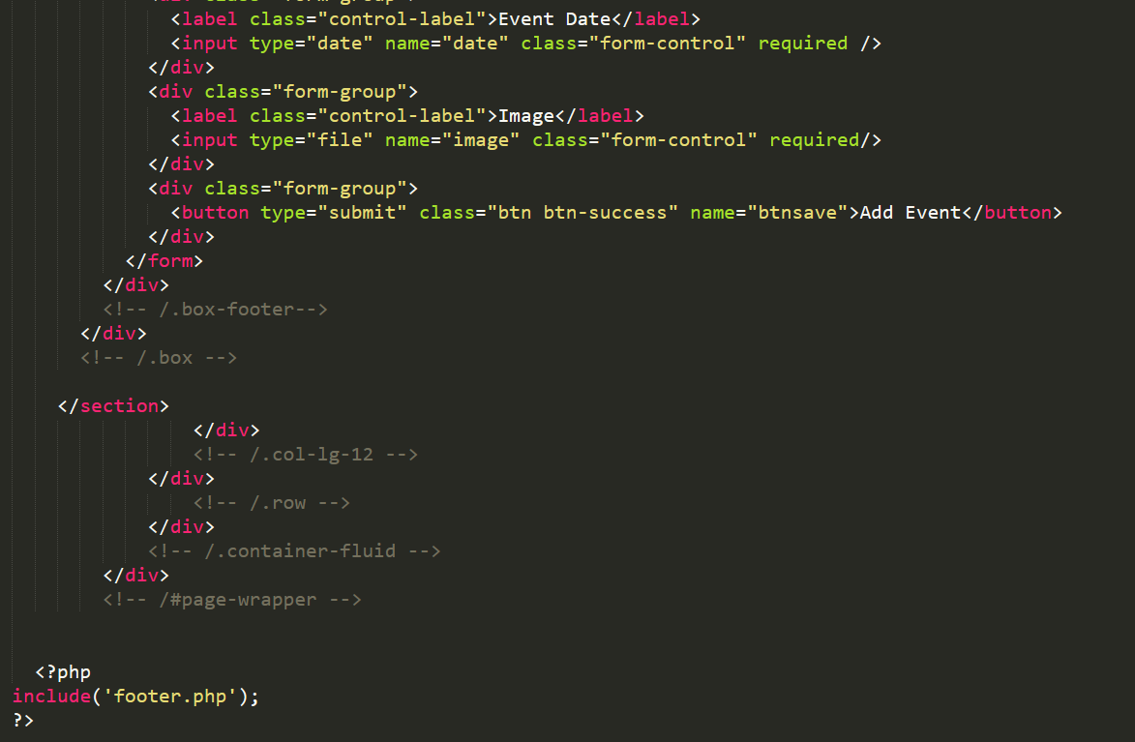

Figure 36 Codes of Add events

Add tickets:

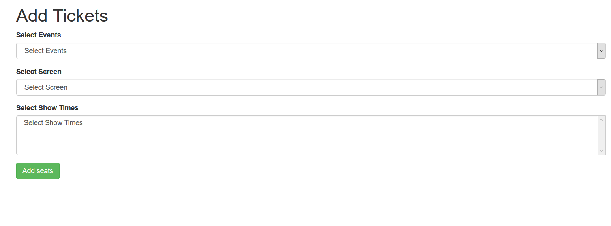

Figure 37 Add tickets

Codes of Add tickets:

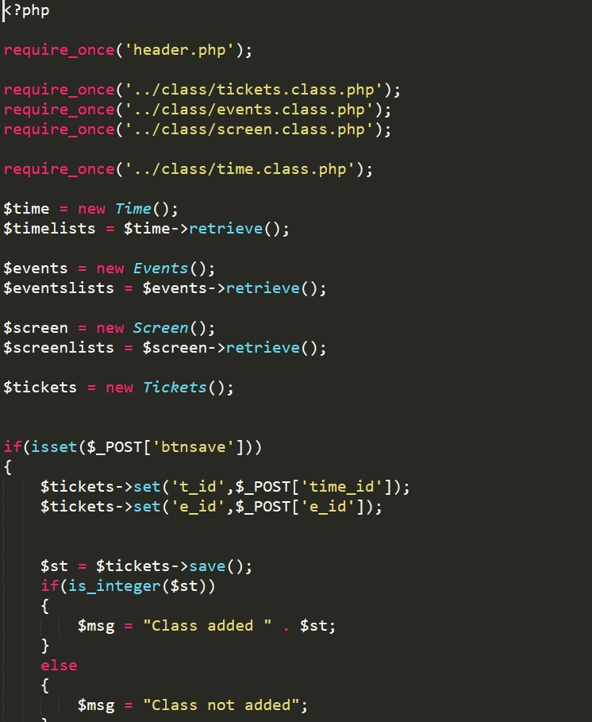

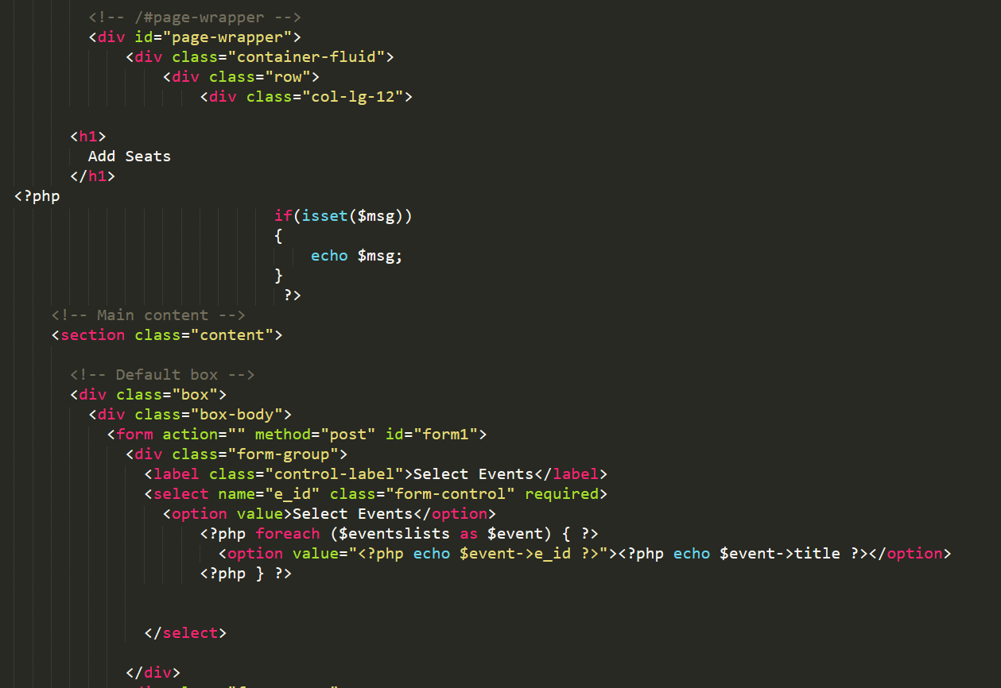

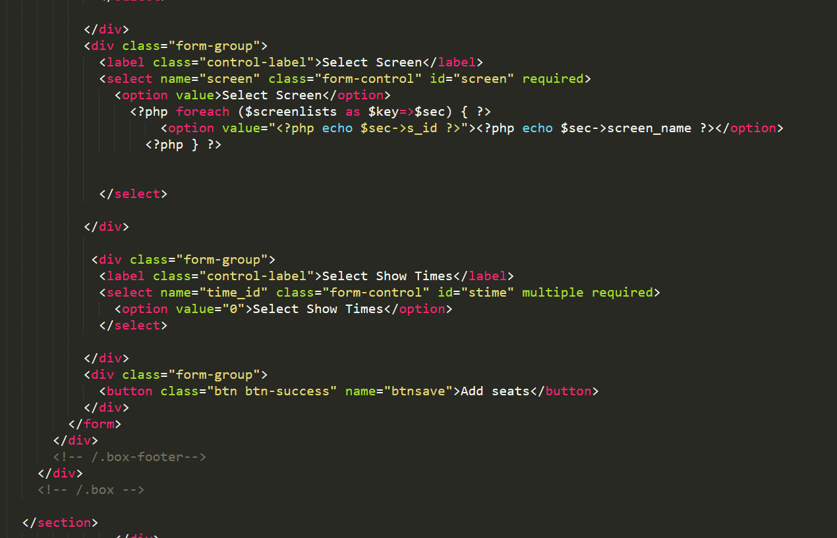

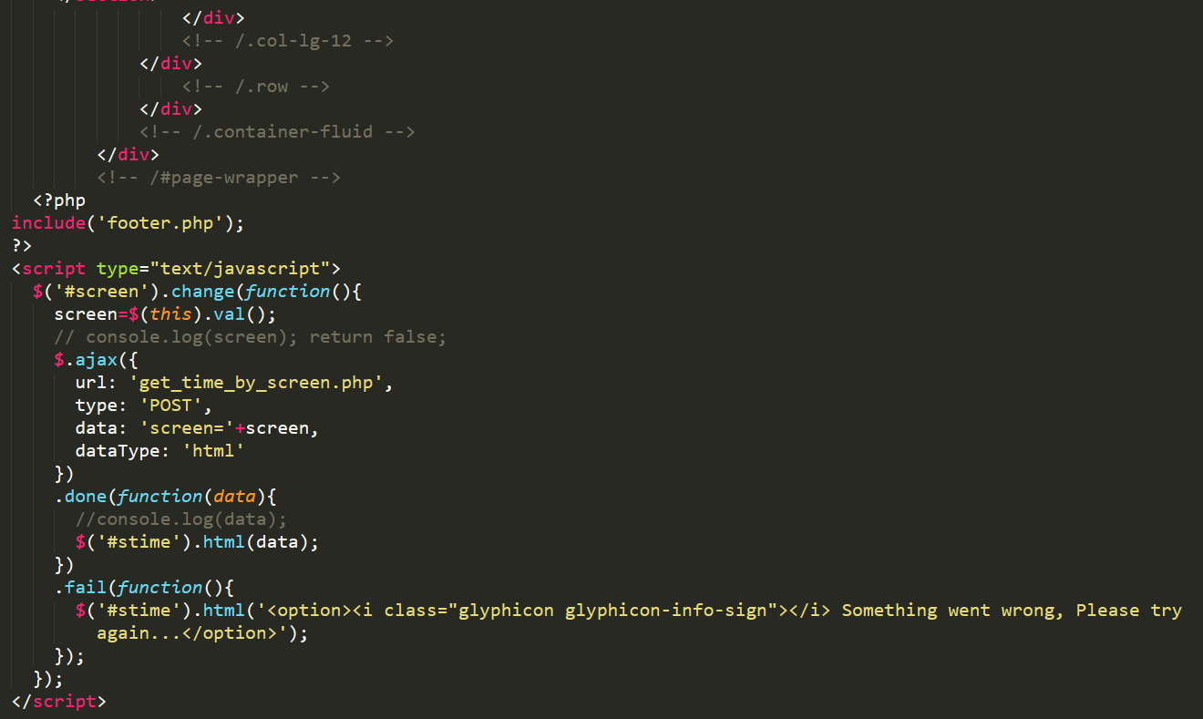

Figure 38 Codes of Add tickets

Add screen details:

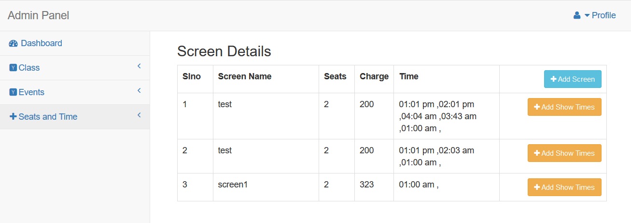

Figure 39 screen details

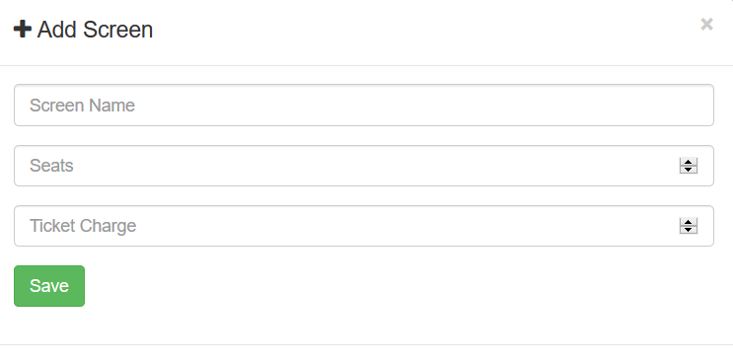

Figure 40 Add screen

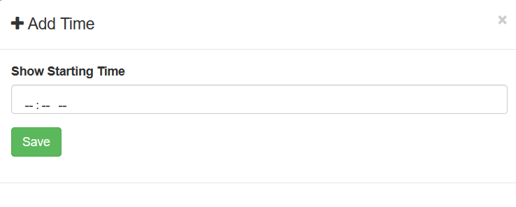

Figure 41 Add time

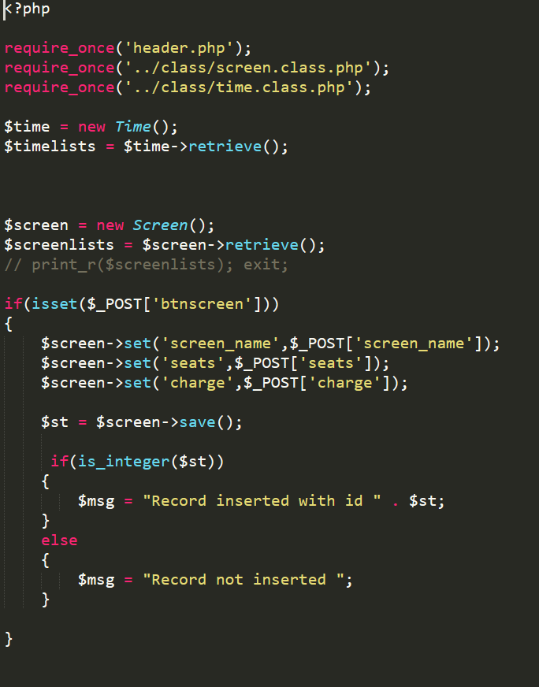

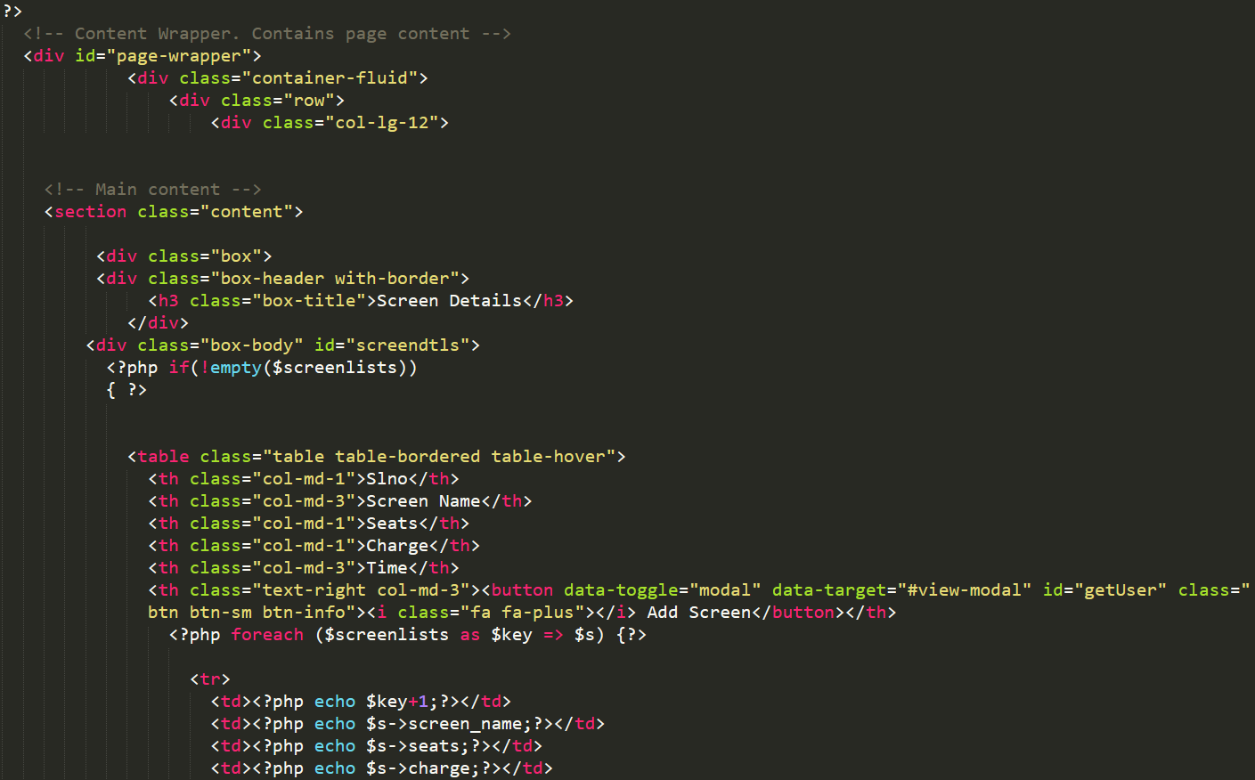

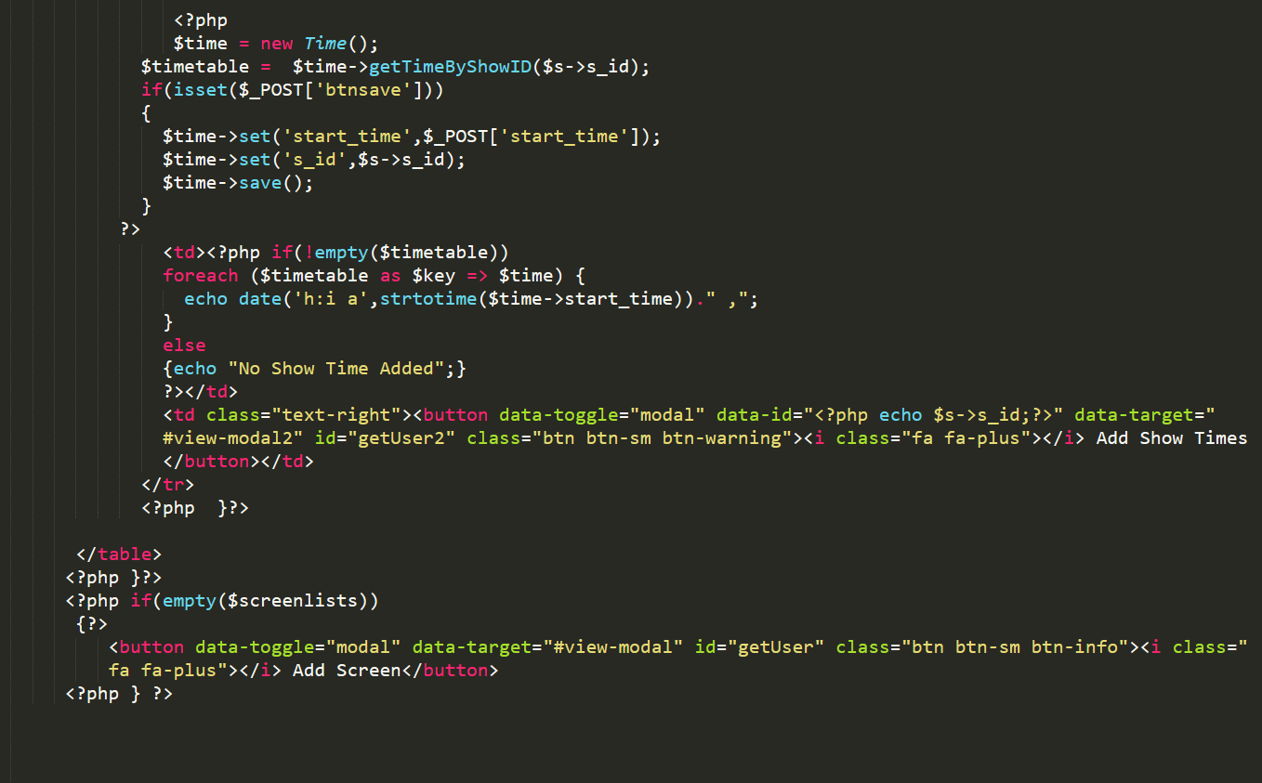

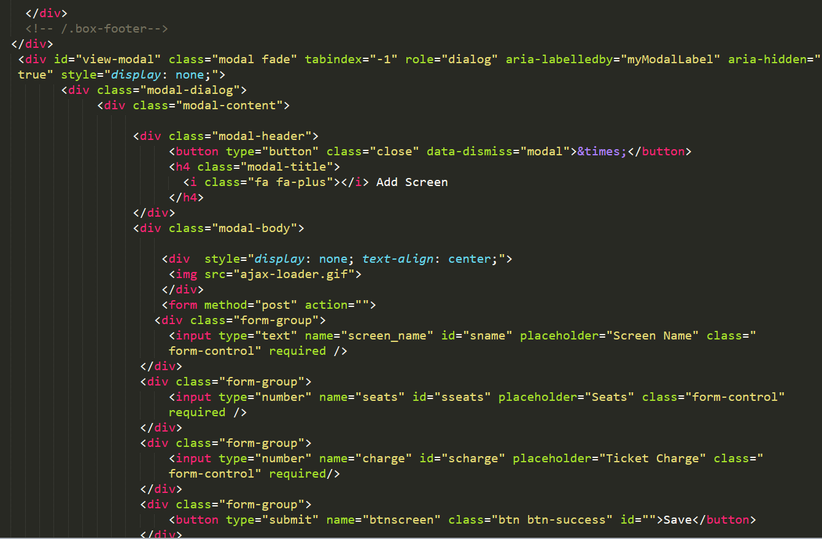

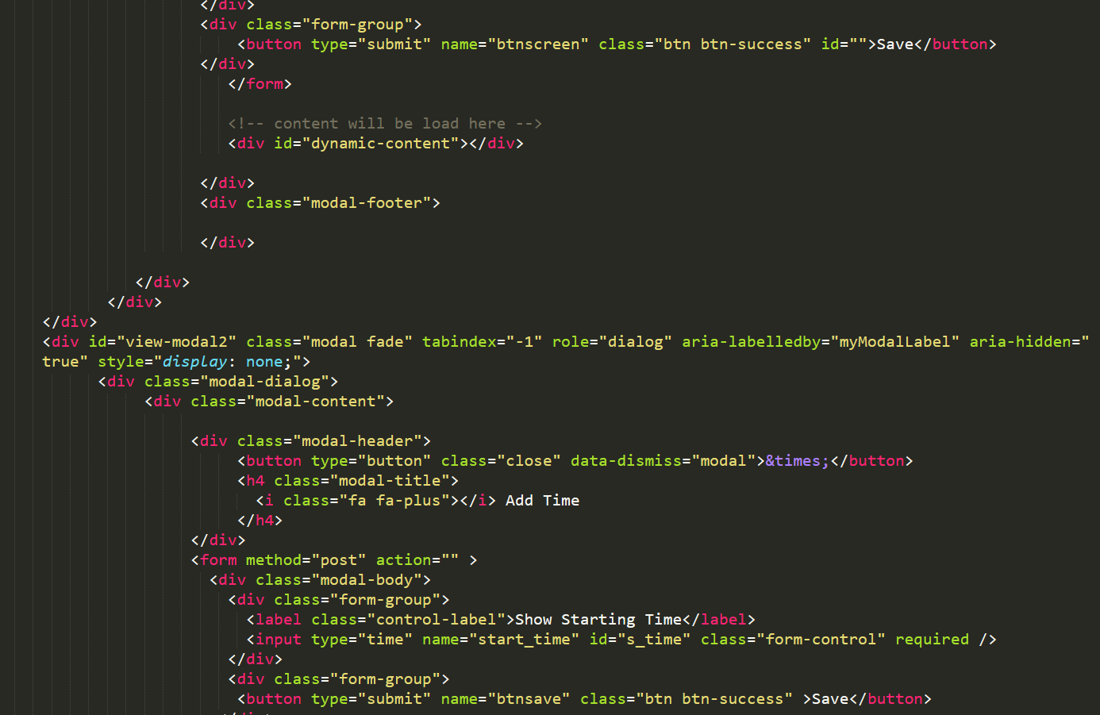

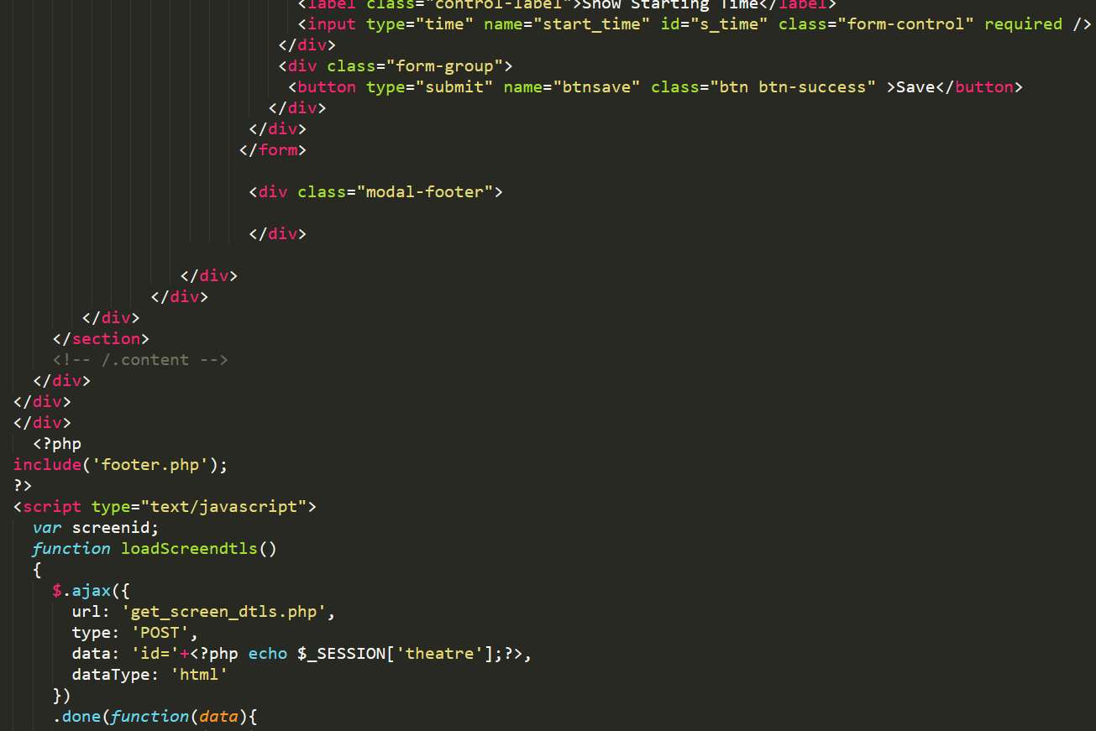

Figure 42 code of screen and time

Search :

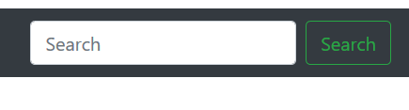

Figure 43 search

Codes of search:

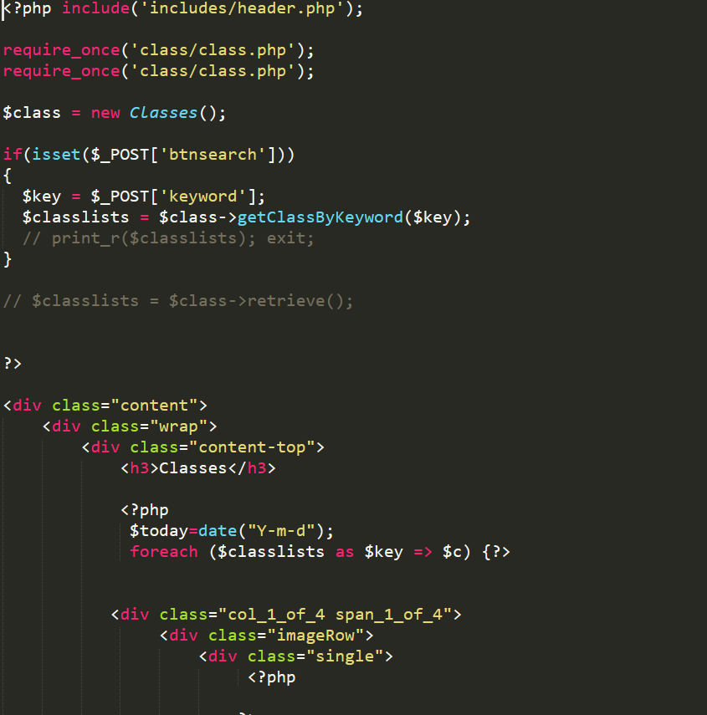

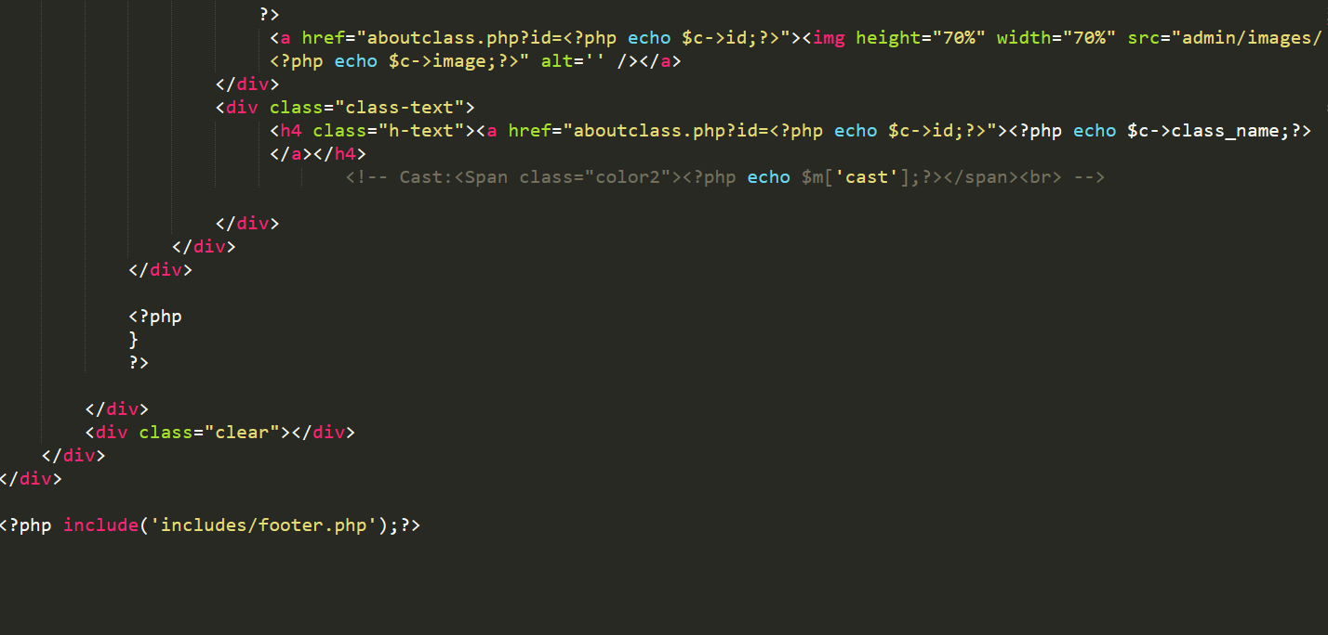

Figure 44 Codes of search

Class detail:

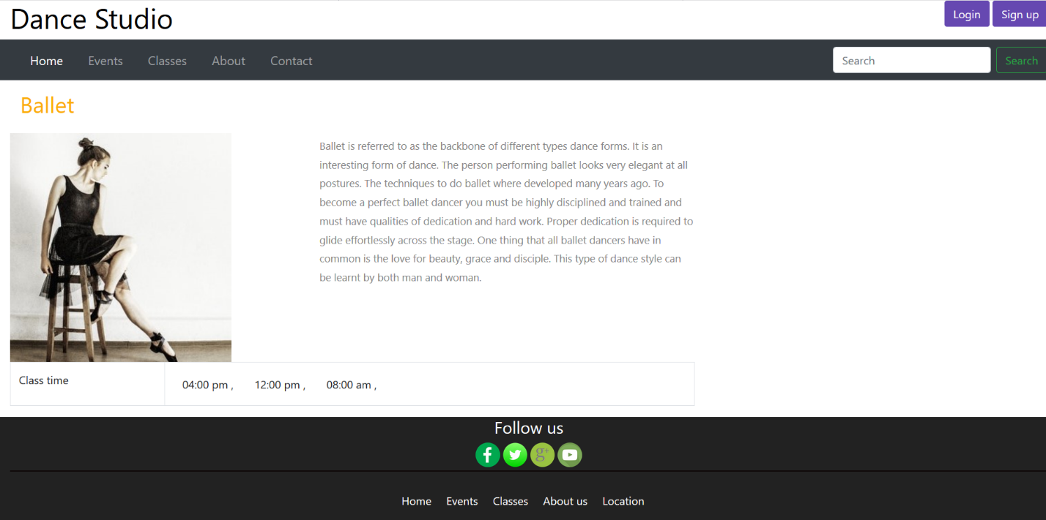

Figure 45 Class detail

Codes of Class detail:

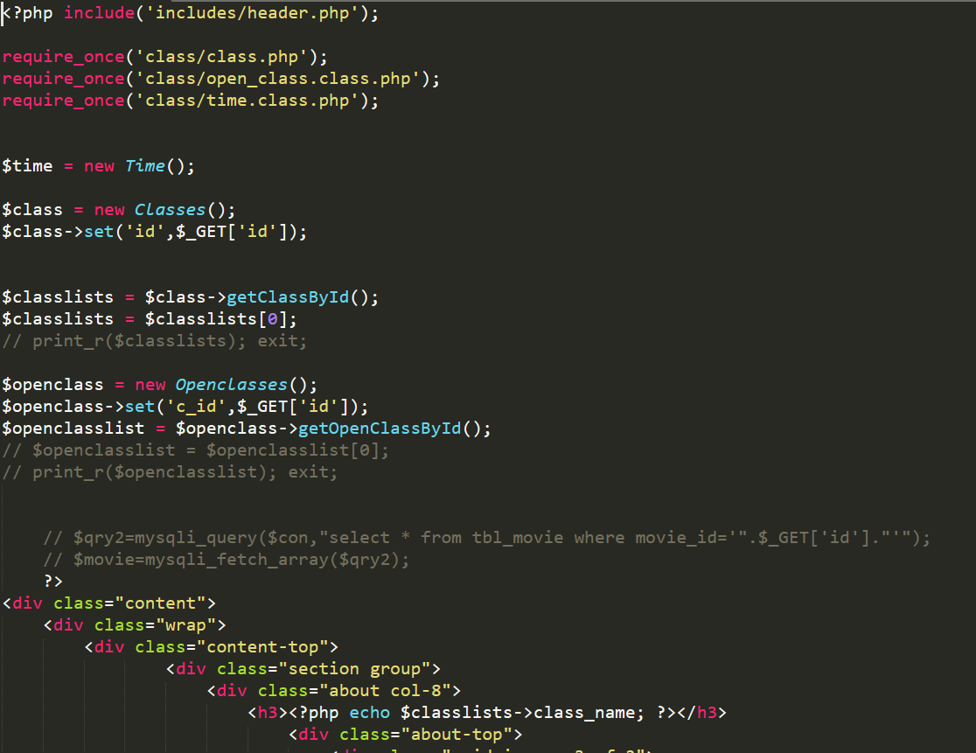

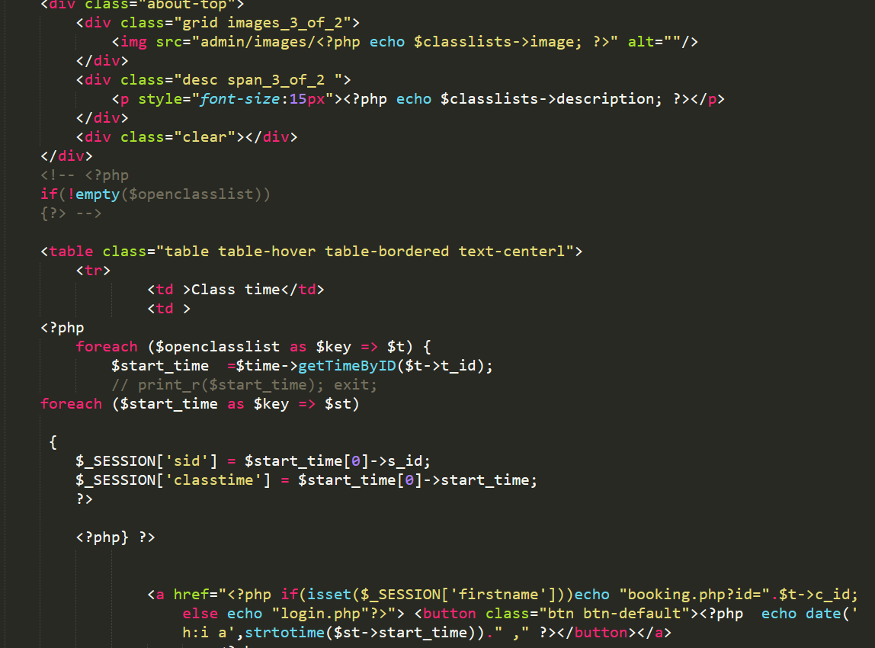

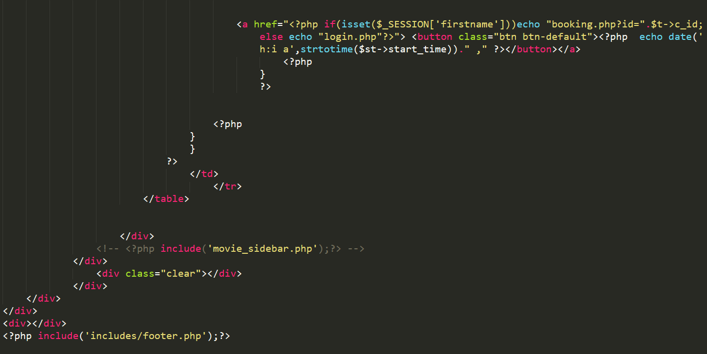

Figure 46 codes of Class detail

Class booking:

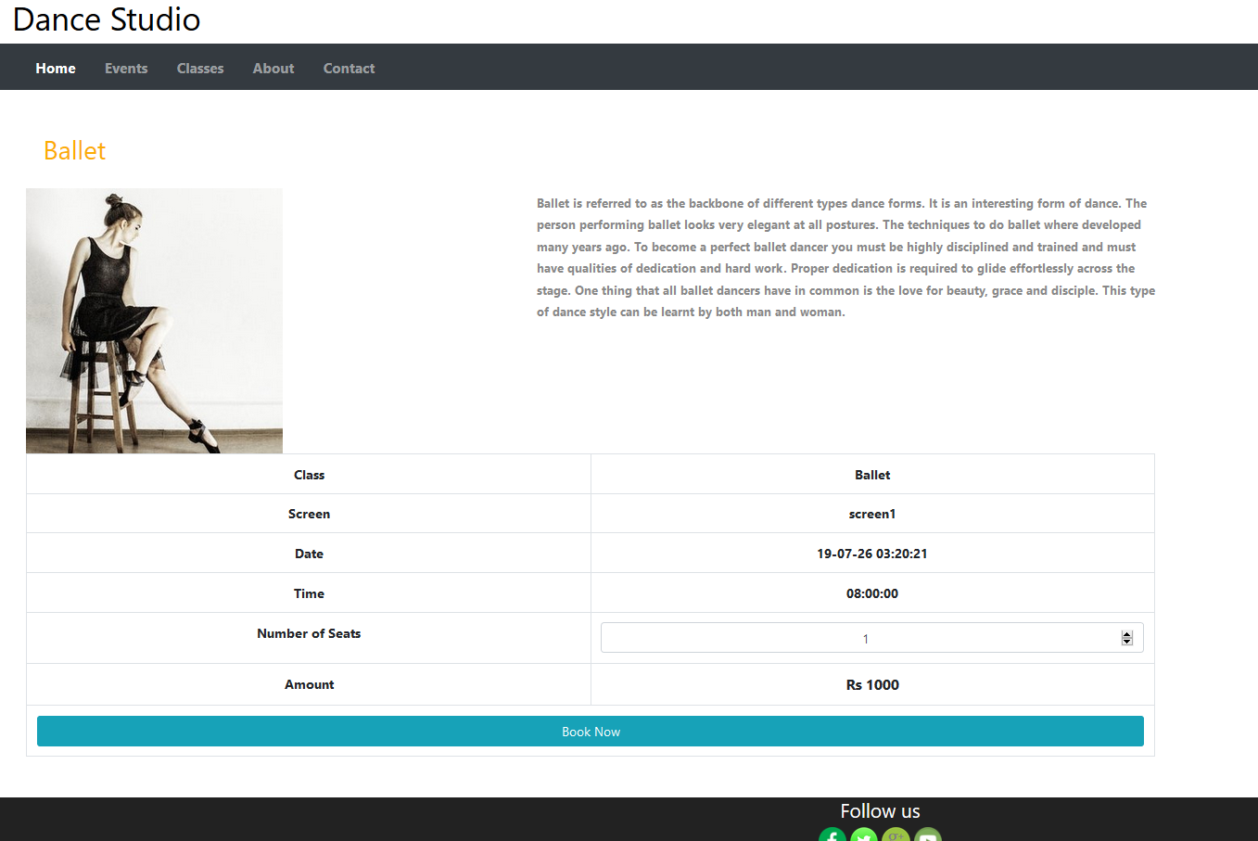

Figure 47 Class booking

Codes of Class booking:

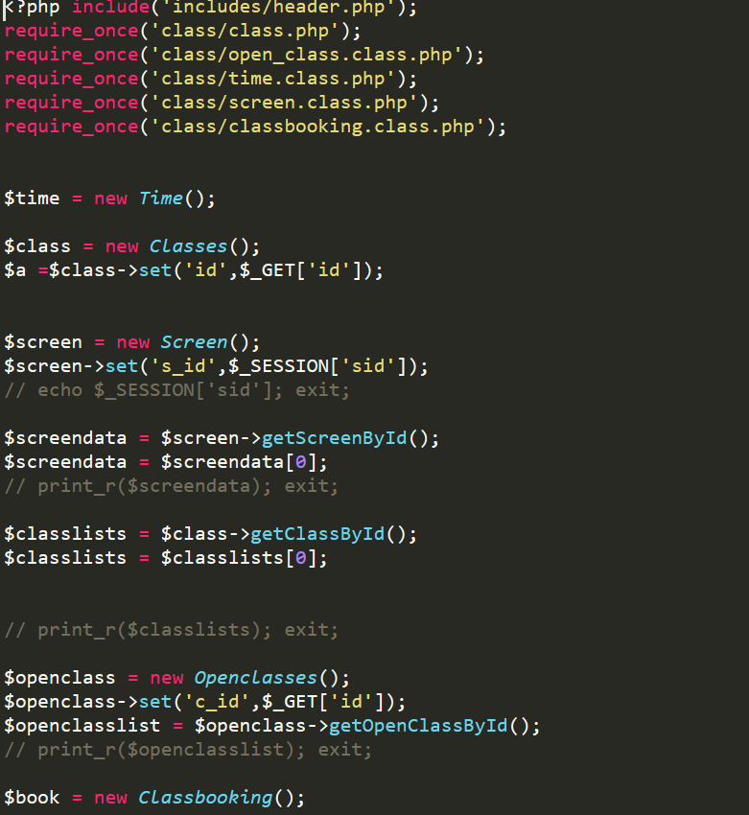

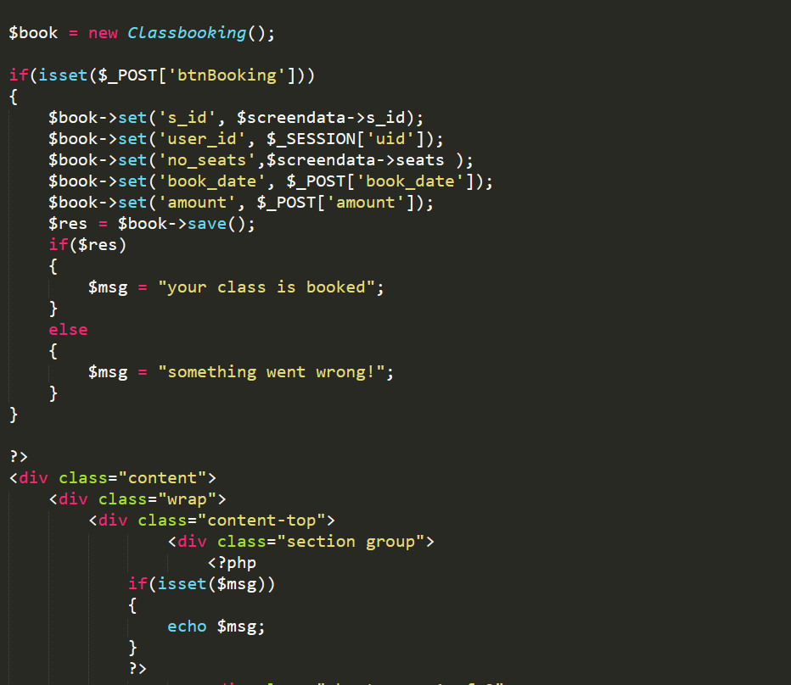

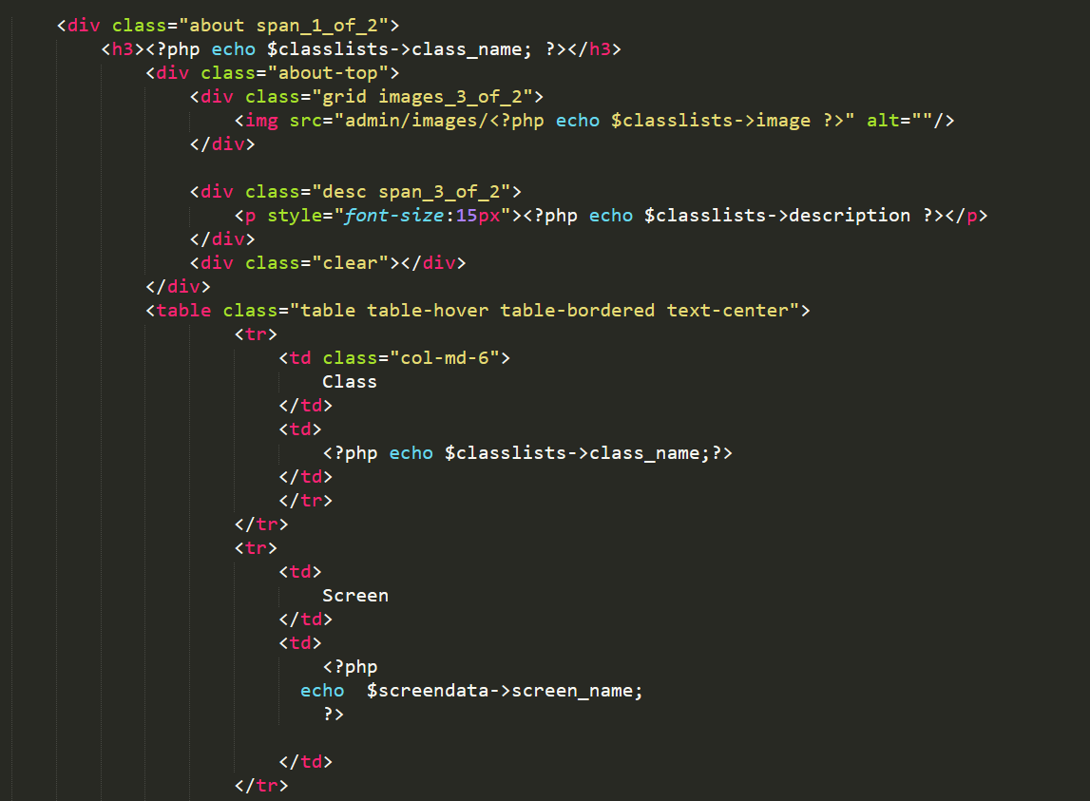

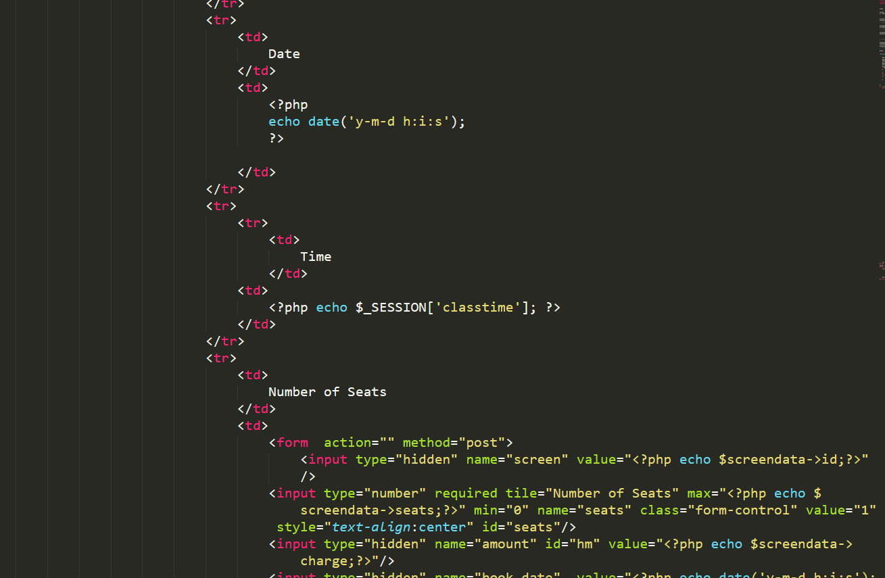

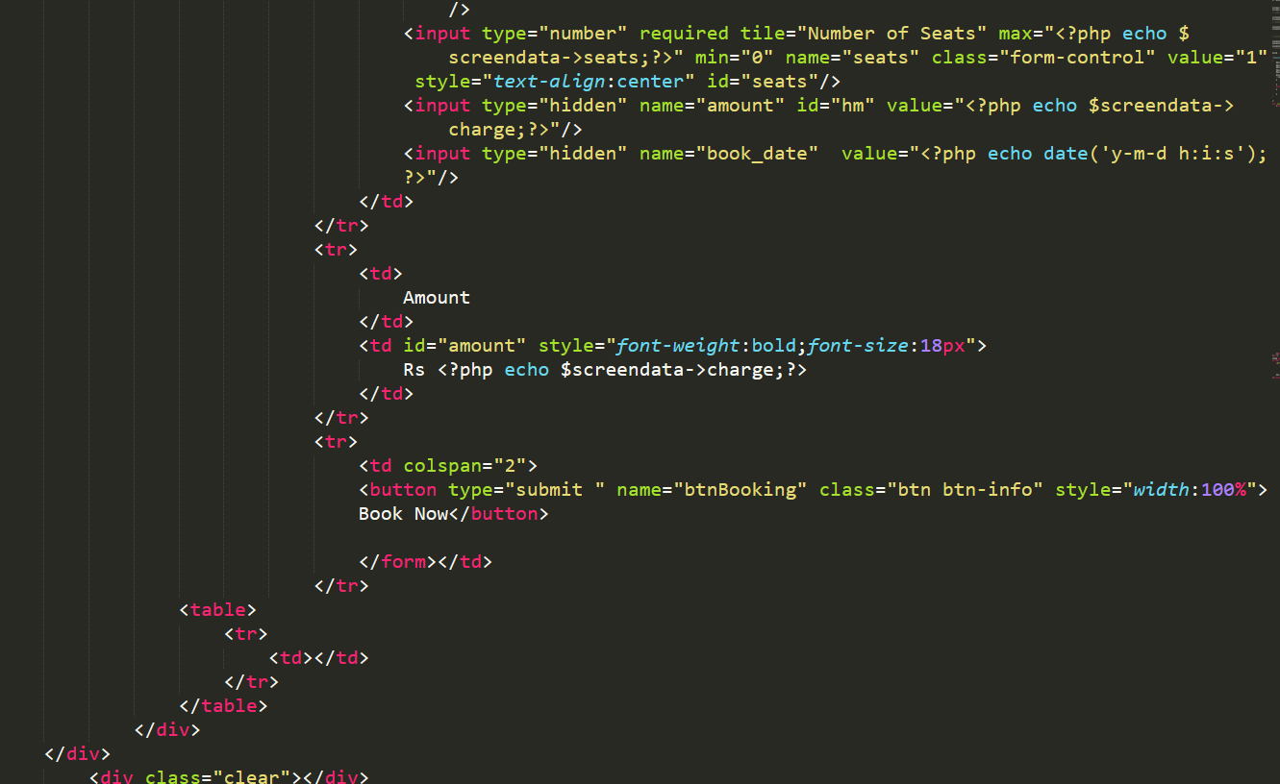

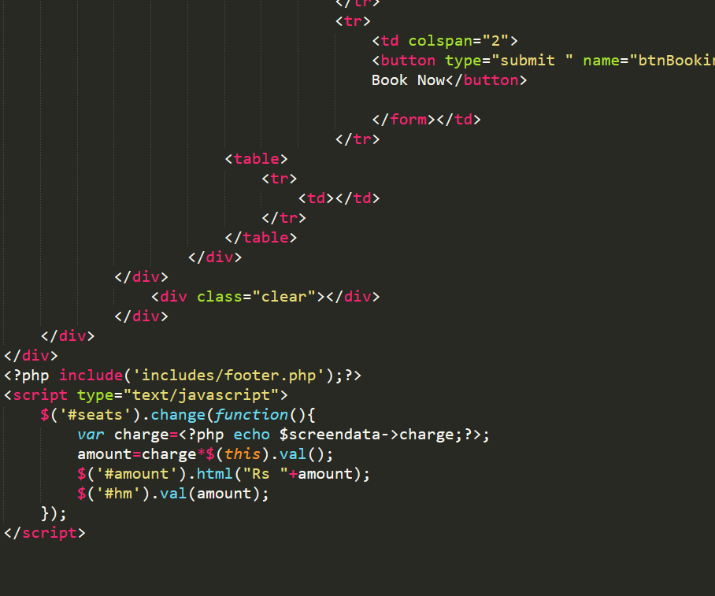

Figure 48 codes of Class booking

# **Chapter – 5: Testing**

## **Introduction**

Once the software is complete, it is sent for testing to test for bugs in it. And the functionality of the entire system is checked in this this phase. This phase is done for verifying if the application works as customer’s requirement.

During this phase application is tested and if bugs are found they are to fixed it, this cycle goes on until all caught bugs are fix.

There are many ways of software testing among them I am performing Black Box testing.

## **5.1 Black Box Testing**

Black Box Testing also known as Behavioral Testing, is a software testing method in which design/internal structure of the system being tested is not known to the tester. The tests done in this method can be both functional or non-functional, though usually functional.

The tests performed in the system are given below:

|  |  |  |  |  |  |
| --- | --- | --- | --- | --- | --- |
| Title: Dance Studio | | | | | |
| Test Case ID: T1 to T3 | | | Designed By: Sujit Khadgi | | |
| Test Name: Register | | | Date of Design: 14th June, 2019 | | |
| Test Description: Registration validation | | | Executed By: Sujit Khadgi | | |
| Date of Execution: 28th July, 2019 | | |
| **Test id** | **Test case** | **Text data** | **Expected result** | **Actual result** | **result** |
| T1 | Check with empty field | - | User should get data require message. | User got error message for empty fields. | Passed |
|  | | | | | |
| T2 | Register with invalid data | First name, last name,  Address,  Gender,  Date of birth  Email, phone, and password | User should get data invalid message. | User got invalid data message. | Passed |
|  | | | | | |
| T3 | Register with valid data | First name, last name,  Address,  Gender,  Date of birth  Email, phone, and password | User should be able register new account. | New user registration successful. | Passed |
|  | | | | | |

|  |  |  |  |  |  |
| --- | --- | --- | --- | --- | --- |
| Title: Dance Studio | | | | | |
| Test Case ID: T4 to T6 | | | Designed By: Sujit Khadgi | | |
| Test Name: Login testing | | | Date of Design: 14th June, 2019 | | |
| Test Description: Login validation | | | Executed By: Sujit Khadgi | | |
| Date of Execution: 28th July, 2019 | | |
| **Test id** | **Test case** | **Text data** | **Expected result** | **Actual result** | **result** |
| T4 | Login with wrong email | email | User should get message as Email does not exists | User got error message as Email does not exists. | Passed |
|  | | | | | |
| T5 | Try to login with less than 6-word password | Email and password | User should get message as Please enter at least 6 characters. | User got error message as Please enter at least 6 characters. | Passed |
|  | | | | | |
| T6 | Login with valid account | Email and password | User should be able to login. | Login successful. | Passed |
|  | | | | | |

|  |  |  |  |  |  |
| --- | --- | --- | --- | --- | --- |
| Title: Dance Studio | | | | | |
| Test Case ID: T7 to T8 | | | Designed By: Sujit Khadgi | | |
| Test Name: Add class and seats | | | Date of Design: 14th June, 2019 | | |
| Test Description: Add class and seats for those class | | | Executed By: Sujit Khadgi | | |
| Date of Execution: 28th July, 2019 | | |
| **Test id** | **Test case** | **Text data** | **Expected result** | **Actual result** | **result** |
| T7 | Try adding empty data | - | User should get message as fill out this form | User got error message as fill out the form | Passed |
|  | | | | | |
| T6 | Add valid class data | Class name, Description, and image | Adding successful and get message for it. | Class is added and got inserted message. | Passed |
|  | | | | | |
| T7 | Add seats with empty fields | - | User should get message as fill out this form | User got error message to fill out the form | Passed |
|  | | | | | |
| T8 | Add seats data | Class name, Screen, and Time | Adding successful and get message for it. | Seats is added and got instead message. | Passed |
|  | | | | | |

|  |  |  |  |  |  |
| --- | --- | --- | --- | --- | --- |
| Title: Dance Studio | | | | | |
| Test Case ID: T9 to T12 | | | Designed By: Sujit Khadgi | | |
| Test Name: event and tickets | | | Date of Design: 14th June, 2019 | | |
| Test Description: adding events and tickets into it. | | | Executed By: Sujit Khadgi | | |
| Date of Execution: 28th July, 2019 | | |
| **Test id** | **Test case** | **Text data** | **Expected result** | **Actual result** | **result** |
| T9 | Try adding empty data | - | User should get message as fill out this form | User got error message as fill out the form | Passed |
|  | | | | | |
| T10 | Add valid event data | Event title, Description, Event date and image | Adding successful and get message for it. | Class is added and got inserted message. | Passed |
|  | | | | | |
| T11 | Add tickets with empty fields | - | User should get message as fill out this form | User got error message to fill out the form | Passed |
|  | | | | | |
| T12 | Add tickets data | Event title, Screen, and Time | Adding successful and get message for it. | Seats is added and got instead message. | Passed |
|  | | | | | |

|  |  |  |  |  |  |
| --- | --- | --- | --- | --- | --- |
| Title: Dance Studio | | | | | |
| Test Case ID: T13 to T17 | | | Designed By: Sujit Khadgi | | |
| Test Name: Screen test | | | Date of Design: 14th June, 2019 | | |
| Test Description: Adding seats and amount | | | Executed By: Sujit Khadgi | | |
| Date of Execution: 28th July, 2019 | | |
| **Test id** | **Test case** | **Text data** | **Expected result** | **Actual result** | **result** |
| T13 | Try adding empty data | - | User should get message as fill out this form | User got error message as fill out the form | Passed |
|  | | | | | |
| T14 | Enter invalid data | Screen, seats, and tickets charge | Invalid message, enter number. | Invalid message, enter number. | Passed |
|  | | | | | |
| T15 | Add valid screen data | Screen, seats, and tickets charge | Screen is added. | Screen successfully added | Passed |
|  | | | | | |
| T16 | Add time with empty fields | - | User should get message as fill out this form | User got error message to fill out the form | Passed |
|  | | | | | |
| T17 | Add valid time | time | Time should be added successfully. | Time is added successfully. | Passed |
|  | | | | | |

|  |  |  |  |  |  |
| --- | --- | --- | --- | --- | --- |
| Title: Dance Studio | | | | | |
| Test Case ID: T18 to T19 | | | Designed By: Sujit Khadgi | | |
| Test Name: booking | | | Date of Design: 14th June, 2019 | | |
| Test Description: booking class | | | Executed By: Sujit Khadgi | | |
| Date of Execution: 28th July, 2019 | | |
| **Test id** | **Test case** | **Text data** | **Expected result** | **Actual result** | **result** |
| T18 | Select time for class for booking without logging in | - | If user is not logged in then it should go to login page | User got into page login. | Passed |
|  | | | | | |
| T19 | Choose time and number of seats to book | Number of seats | Booking should be successful | Booking successful. | Passed |
|  | | | | | |

|  |  |  |  |  |  |
| --- | --- | --- | --- | --- | --- |
| Title: Dance Studio | | | | | |
| Test Case ID: T20 to T21 | | | Designed By: Sujit Khadgi | | |
| Test Name: contact us | | | Date of Design: 14th June, 2019 | | |
| Test Description: sending mail to studio | | | Executed By: Sujit Khadgi | | |
| Date of Execution: 28th July, 2019 | | |
| **Test id** | **Test case** | **Text data** | **Expected result** | **Actual result** | **result** |
| T20 | Send empty message | - | User should get message as fill out this form | User got error message as fill out the form | Passed |
|  | | | | | |
| T21 | Send valid message | Name, email, and, message | Message should be sent successfully. | Message sent successfully. | Passed |
|  | | | | | |

# **Chapter – 6: Other Project Issues**

While completing this project there many issues that arises from beginning to end, from analysis to designing, implementing, testing and final deployment. There were many difficulties that needed to be tackled during this project and after tackling those problems this project got its aim.

## **6.1 Other Project Issues**

During the development of the project I faced some issues and they are given below:

* **Issue with developing tool:** During implementation phase XAMPP stopped running localhost which led to delay in coding.

Solution: Reinstalling XAMPP software which worked.

* **Lack of skill**: Being new to Object Oriented PHP which made coding hard making mistake in many codes.

Solution: Practicing from internet and help from teacher and friends made work easier.

* **Limited time**: Every project has limited time to be developed and, in this project, this limited time became great issue for me I needed to learn Object Oriented PHP since I was new to it also got some health issue.

Solution: managing time, getting help from friends and health care.

* **Designing:** In designing phase there were many minor problems with my diagrams.

Solution: got help from teachers.

## **6.2 Project Limitation**

In Dance Studio project as like any other project it got its own limitation. With too many things to complete some of got left out as limitation. Following are the limitation of this project:

* **Online communication:** There is no online communication for user because of time limit and lack of knowledge.
* **Online booking cancelation:** User cannot cancel their booking online. For cancelling booking they need to contact studio and inform them and studio will cancel their booking.
* **Advertisement:** members of studio or products cannot be boost.

## **6.3** **Future Work**

When developing a program some useful and required functions gets left out due to some difficulties that arises during developing process. But some of them might get added in future works and here is some function that will be added in the future works are:

* **Online communication:** Its already a complete project but in future by adding online communication in function then it will take this application to next level.
* **Online Booking Cancellation:** this function is going to be included in future so that user can cancel their booking as they want.
* **Advertisement:** With this function both Dance Studio and Member will be able to advertise their works and product.
* **Online Shop:** Dance studio is a platform for artists and artists create works/product which will be sold in this function.

## **6.4 Risk Management**

Risk management means risk containment and reduction of risk. First, you’ve got to identify and plan. Then be ready to act when a risk arises, drawing upon the experience and knowledge of the entire team to minimize the impact to the project. 

|  |  |  |  |  |  |
| --- | --- | --- | --- | --- | --- |
| S. No | Risk | Likelihood | Consequence | Impact | Remark |
| 1 | Hard disk failure | 2 | 4 | 8 | Make Backup data and store in online drive. |
| 2 | Data loss | 2 | 4 | 8 | Make Backup data and store in online drive. |
| 3 | Time limitation | 2 | 3 | 6 | Planning workable timetable and keep up with. |
| 4 | Natural disaster | 1 | 5 | 5 | Operating in low rate of disaster and creating policy for recovery. |
| 5 | Change in requirement | 2 | 3 | 6 | Getting in contact with client and users |
| 6 | Sickness | 1 | 3 | 3 | Maintaining health properly and have some backup plan |
| 7 | Code failure | 2 | 4 | 8 | Test properly |

## **6.5 Configuration Management**

Configuration management encompasses the administrative activities concerned with the creation, maintenance, controlled change and quality control of the scope of work.

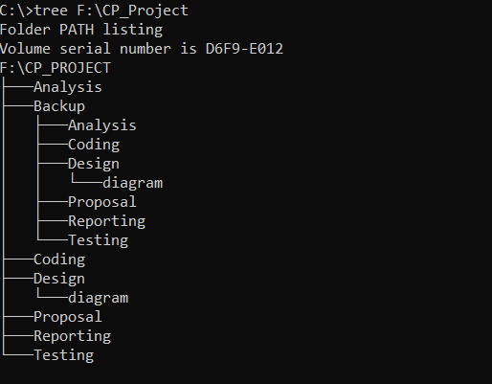

## **6.6 User Manual**

**User Manual – guide for dance studio website**

How to Register?

* Click on sign up button on top right side of website.
* Enter your valid information.
* Then click on register button.
* After that if you have enter information correctly then it will take you to login page otherwise you will get error message.



How to Login?

* If you don’t have account then first register and if u have already registered then click on Login.
* Enter your correct email and password.
* Click on login button
* If your email or password is incorrect then u will get error message

Else

* You will be sent to dashboard.



How to book class?

* First search classes available
* Choose class you want to book
* Then choose time you want to attend the class
* After that if you are not login then you will be sent to login page
* But if you are logged in then you will be sent to class details page
* Then choose how many seats you want to book
* Click on Book now button
* Then you will get booking success message.

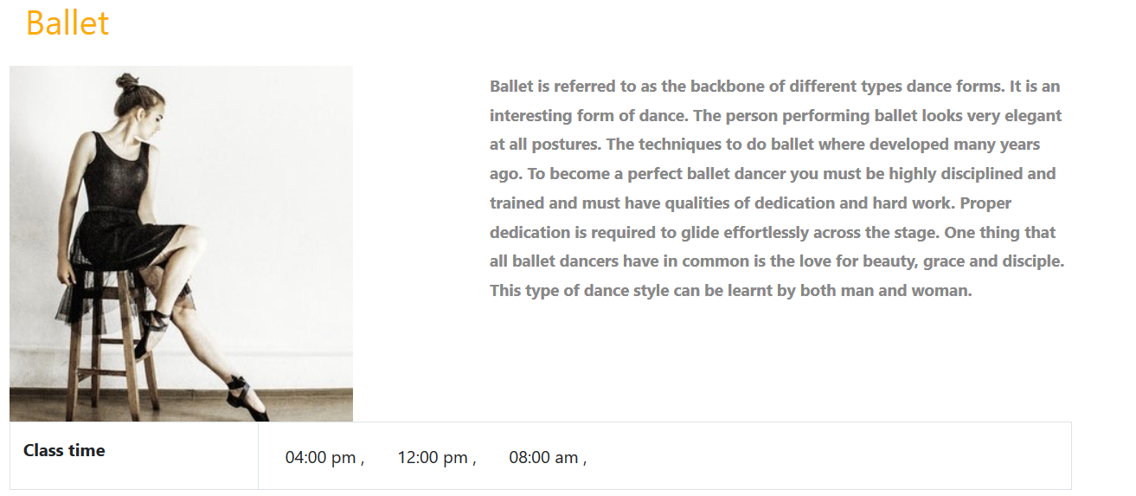

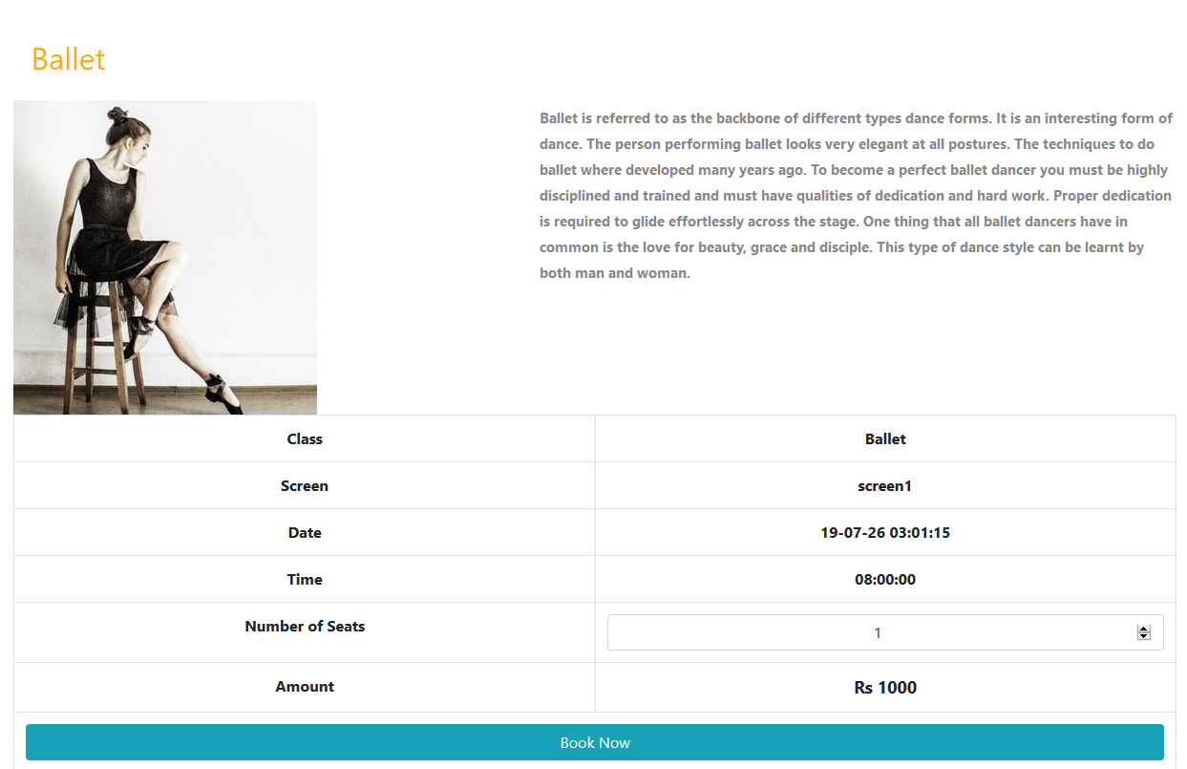

# **Conclusion**

For the start of this new project first I had to submit the proposal where I introduced the purpose of the projects, its background, problems statement, aims and objectives and some risk factors and its solutions. After that this project went on path of development.

First thing I did was analysis on this project after it got accepted. It was hard to get required information because of its being new concept for dance studio to go on market with website in my town. I choose waterfall development methodology for this project being its traditional approach. With the help of MoSCoW prioritization it made easy to set up functional and non-functional requirements.

Designing is made easy to understand and use for development. For this phase I used many designs like class diagram, activity diagram, sequence diagram, ER-diagram etc. this phase took too much time to correct errors in those diagrams.

For implantation phase I used object-oriented PHP which I was new to it and it took time to learn to code and to correct errors was hard because of lack of knowledge at start. But later it got ok with time. For testing I have done black box testing to test the functionality of the system.

So lastly, final documentation is made so readers can understand what this project is about, what is done in this project, and is it good or not.

# **Appendix**

